**Project-1**

**Title: Write a Simple HTML program for displaying ”Hello World!”:**

**Source code:**

<!DOCTYPE html>

<html>

    <head>

        <title>

            First web page

        </title>

    </head>

    <body>

        Hello World!

    </body>

</html>

**Output:**

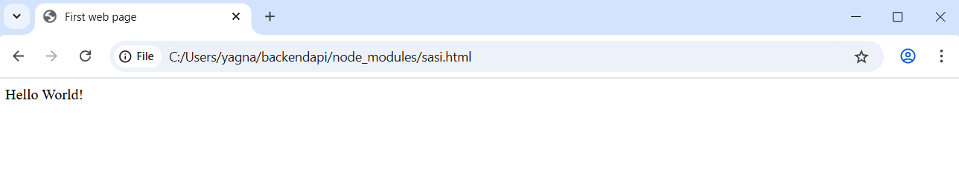

**Project-2**

**Title: Design a web page of displaying “Hello world” by using Heading Tag:**

**Source code:**

<!DOCTYPE html>

<html>

    <head>

        <title>

            Second web page

        </title>

    </head>

    <body>

        <h1>Hello World!</h1>

        <h2>Hello World!</h2>

        <h3>Hello World!</h3>

        <h4>Hello World!</h4>

        <h5>Hello World!</h5>

        <h6>Hello World!</h6>

    </body>

</html>

**Output:**

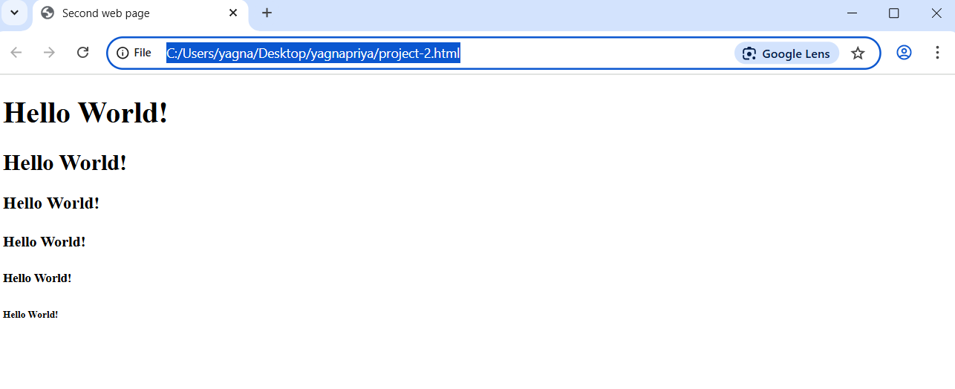

**Project-3**

**Title: Design a web page by demonstrating the usage of Paragraph Tag:**

**Source code:**

<!DOCTYPE html>

<html>

    <head>

        <title>

            Paragraph Tag

        </title>

    </head>

    <body>

        <h1>Paragraph</h1>

        <p>/This is a paragraph.<br>Adding a line break here for demonstration.</p>

        <br>

        <p> This is another paragraph.<br>Here's another line break within this paragraph</p>

        <br>

    </body>

</html>

**Output:**

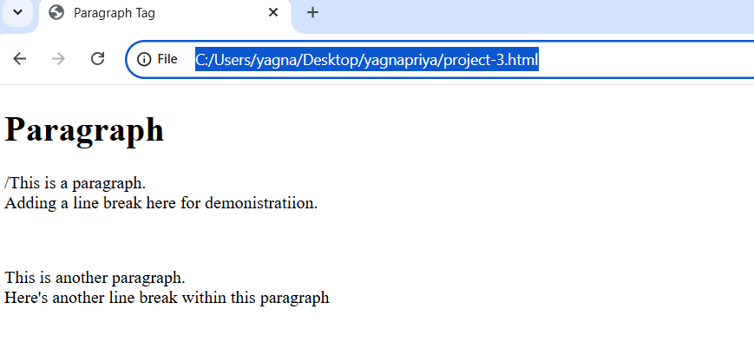

**Project-4**

**Title: Design a web page by demonstrating the usage of HTML lists:**

**Source code:**

<!DOCTYPE html>

<html>

    <head>

        <title>

            HTML lists Example

        </title>

</head>

    <body>

        <h2>Ordered list(numbered)</h2

            <ol>

                <li>Rice</li>

                <li>Sugar</li>

                <li>Dal</li>

            </ol>

            <h2> Unordered list(Bullet Points)</h2>

            <ul>

                <li>Apple</li>

                <li>Orange</li>

                <li>Banana</li>

            </ul>

            <h2>Definition List(Items)</h2>

            <dl>

                <dt>Potato</dt>

            <dd>A starchy vegetable commonly used in cooking.</dd>

            <dt>Brinjal</dt>

<dd>Also known as eggpiant, a versatile vegetable used in various dishes.</dd>

            </dl>

    </body>

</html>

**Output:**

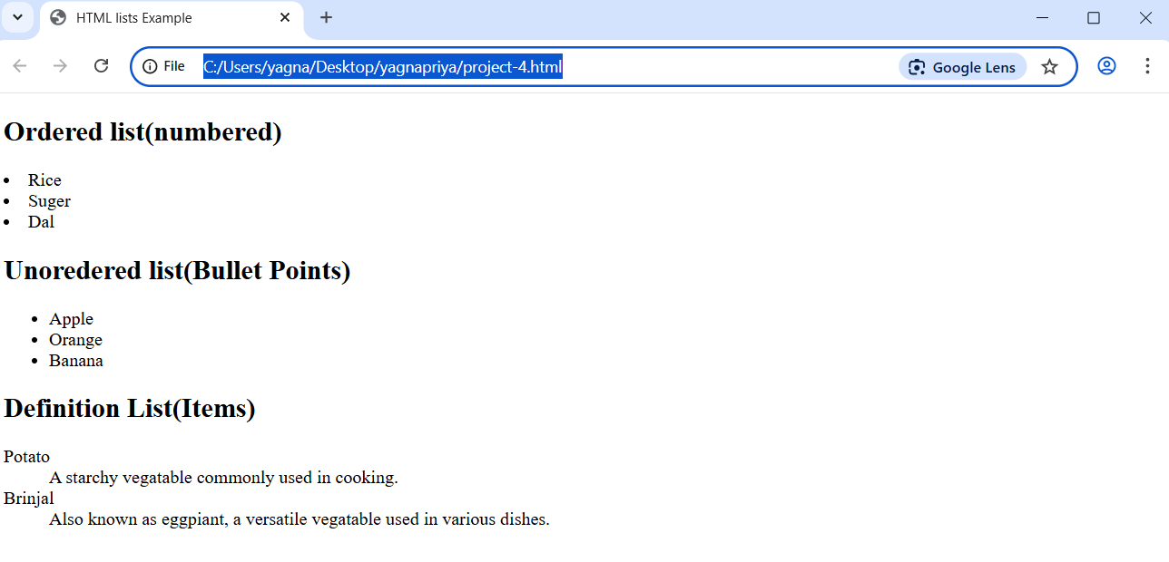

**Project-5**

**Title: To design a web page by demonstrating the usage of HTML list type attribute –“A”:**

**Source code:**

    </body>

</html>

<!DOCTYPE html>

<html>

    <head>

        <title>

            Second web page

        </title>

    </head>

    <body>

        <ol type="A">

            <li>SASI</li>

            <li>LIKKI</li>

            <li>RAM</li>

        </ol>

    </body>

</html>

**Output:**

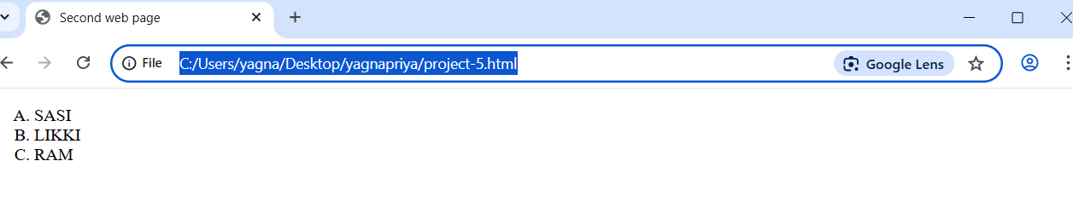

**Project-6**

**Titlte: Design a web page by demonstrating the usage of HTML list type attribute-“a”:**

**Source code:**

<!DOCTYPE html>

<html>

    <head>

        <title>

            Second web page

        </title>

    </head>

    <body>

        <ol type="a">

            <li>SASI</li>

            <li>LIKKI</li>

            <li>RAM</li>

        </ol>

    </body>

</html>

**Output:**

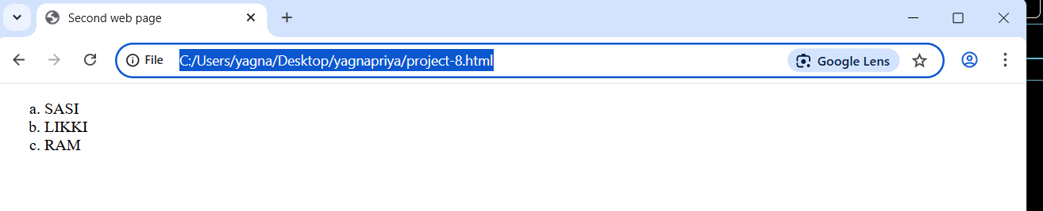

**Project-7**

**Titlte: Design a web page by demonstrating the usage of HTML list type attribute-“I”:**

**Source code:**

<!DOCTYPE html>

<html>

    <head>

        <title>

            Second web page

        </title>

    </head>

    <body>

        <ol type="I">

            <li>SASI</li>

            <li>LIKKI</li>

            <li>RAM</li>

        </ol>

    </body>

</html>

**Output:**

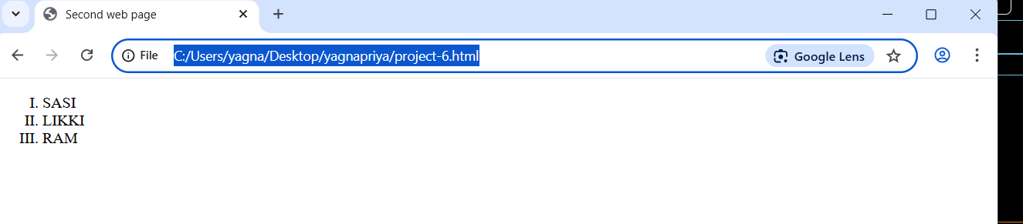

**Project-8**

**Titlte: Design a web page by demonstrating the usage of HTML list type attribute-“i”:**

**Source code:**

<!DOCTYPE html>

<html>

    <head>

        <title>

            Second web page

        </title>

    </head>

    <body>

        <ol type="i">

            <li>SASI</li>

            <li>LIKKI</li>

            <li>RAM</li>

        </ol>

    </body>

</html>

**Output:**

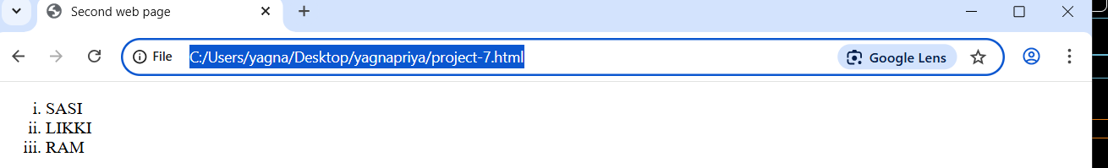

**Project-9**

**Titlte: Design a web page by demonstrating the usage of HTML list with start attribute:**

**Source code:**

<!DOCTYPE html>

<html>

    <head>

        <title>

            Second web page

        </title>

    </head>

    <body>

        <ol start="20">

            <li>SASI</li>

            <li>LIKKI</li>

            <li>RAM</li>

        </ol>

    </body>

</html>

**Output:**

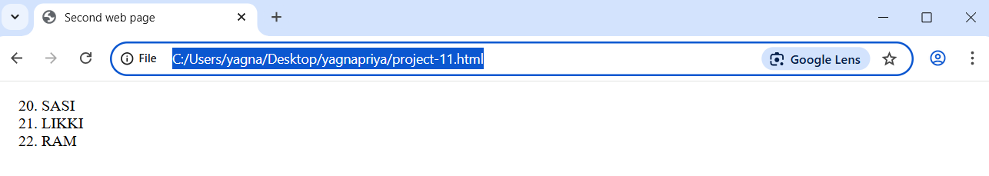

**Project-10**

**Titlte: Design a web page by demonstrating the usage of HTML list type attribute-“square”:**

**Source code:**

<!DOCTYPE html>

<html>

    <head>

        <title>

            Second web page

        </title>

    </head>

    <body>

        <ul type="Square">

            <li>SASI</li>

            <li>LIKKI</li>

            <li>RAM</li>

        </ul>

    </body>

</html>

**Output:**

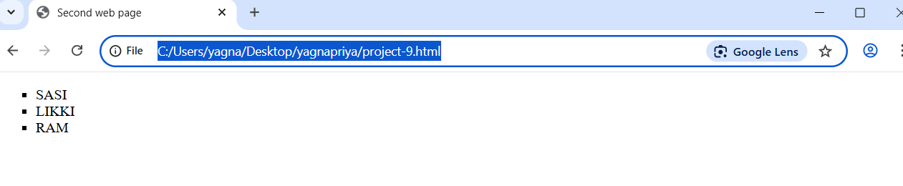

**Project-11**

**Titlte: Design a web page by demonstrating the usage of HTML list type attribute-“circle”:**

**Source code:**

<!DOCTYPE html>

<html>

    <head>

        <title>

            Second web page

        </title>

    </head>

    <body>

        <ul type="circle">

            <li>SASI</li>

            <li>LIKKI</li>

            <li>RAM</li>

        </ul>

    </body>

</html>

**Output:**

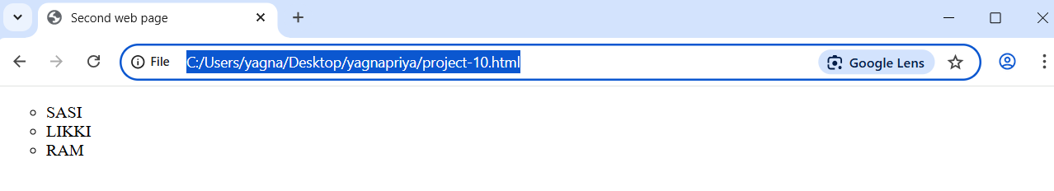

**Project-12**

**Titlte: Design a web page by demonstrating the usage of HTML list type attribute-“disc”:**

**Source code:**

<!DOCTYPE html>

<html>

    <head>

        <title>

            Second web page

        </title>

    </head>

    <body>

        <ul type="disc">

            <li>SASI</li>

            <li>LIKKI</li>

            <li>RAM</li>

        </ul>

    </body>

</html>

**Output:**

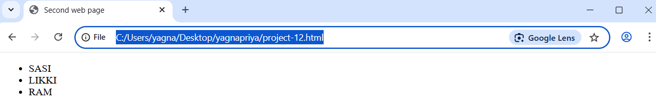

**Project-13**

**Titlte: Design a web page by demonstrating the usage of HTML list type attribute-“none”:**

**Source code:**

<!DOCTYPE html>

<html>

    <head>

        <title>

            Second web page

        </title>

    </head>

    <body>

        <ul type="none">

            <li>SASI</li>

            <li>LIKKI</li>

            <li>RAM</li>

        </ul>

    </body>

</html>

**Output:**

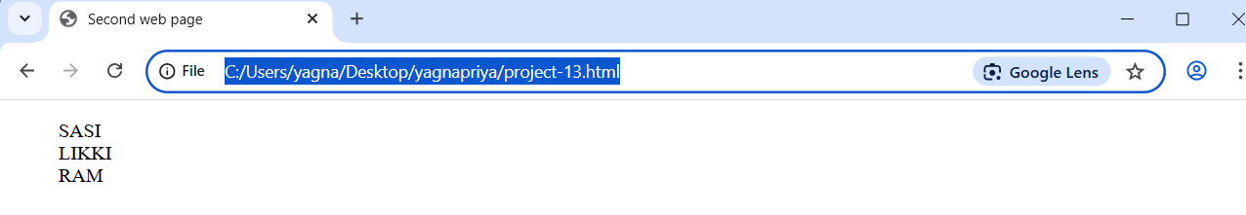

**Project-14**

**Titlte: Design a web page by demonstrating the usage of Nested list in HTML:**

**Source code:**

<!DOCTYPE html>

<html>

    <head>

        <title>

            Second web page

        </title>

    </head>

    <body>

        <ol>

            <li>14 pro</li>

            <li>15 pro</li>

        </ol>

        <li> goggle pixel</li>

        <ol>

            <li>9flod</li>

            <li>9 pro</li>

        </ol>

    </body>

</html>

**Output:**

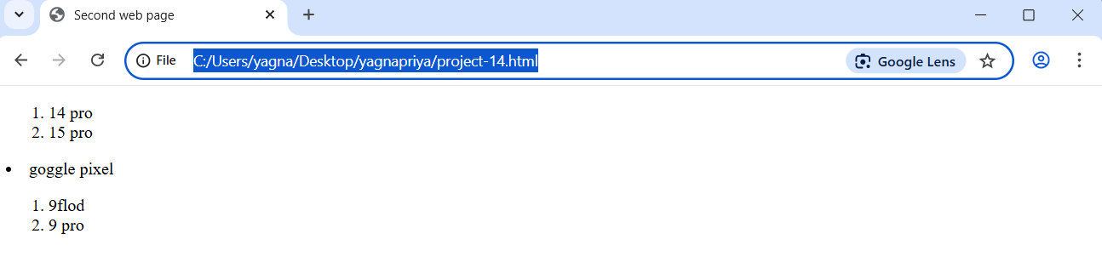

**Project-15**

**Title: Design a web page by demonstrating the usage of HTML Table Tag:**

**Source Code:**

<!DOCTYPE html>

<html>

    <head>

        <title> Table tag</title>

    </head>

    <body>

        <table border="1">

            <tr>

                <th>Name</th>

                <th>Age</th>

                <th>City</th>

            </tr>

            <tr>

                <td>john</td>

                <td>28</td>

                <td>New York</td>

           </tr>

           <tr>

            <td>Emma</td>

            <td>22</td>

            <td>Los Angles</td>

           </tr>

        </table>

    </body>

</html>

**Output:**

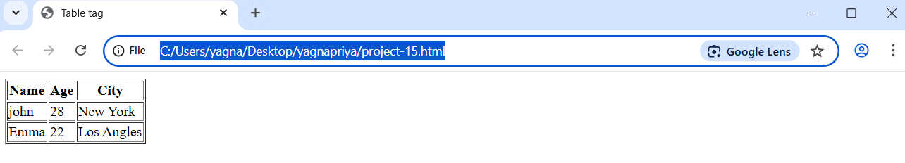

**Project-16**

**Title: Design a web page by demonstrating the usage of HTML. Image Tag.**

**Source Code:**

<!DOCTYPE html>

<html>

<head>

    <title> HTML image</title>

</head>

<body>

    <img src="india.jpg" alt="india flag" height="500" width="700">

</body>

</html>

**Output:**

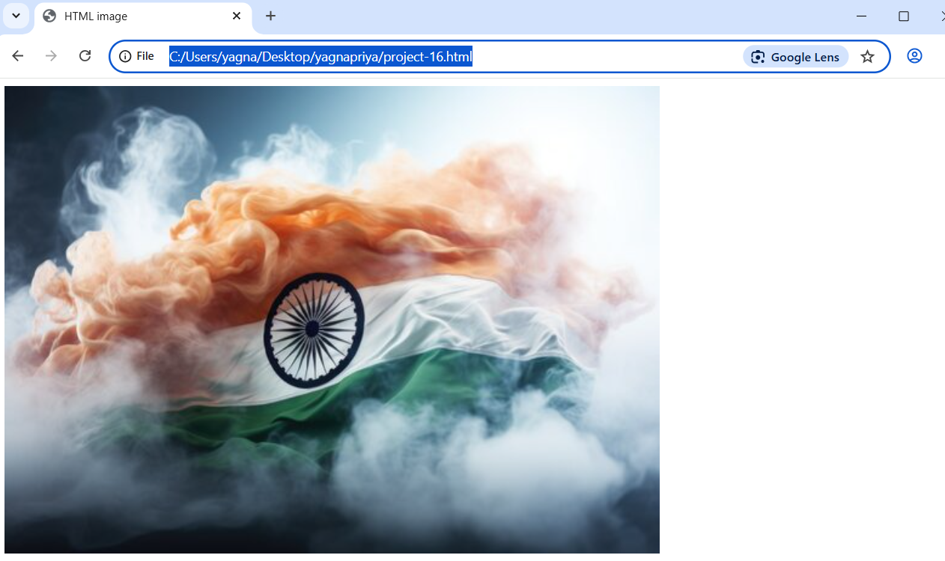

**Project-17**

**Title: Design a web page by demonstrating the usage of HTML. Video Tag.**

**Source Code:**

<!DOCTYPE html>

<html>

    <head>

        <title>

            HTML video

        </title>

        <body>

            <video src="Tree.mp4" height="300" width="600" controls></video>

        </body>

    </head>

</html>

**Output:**

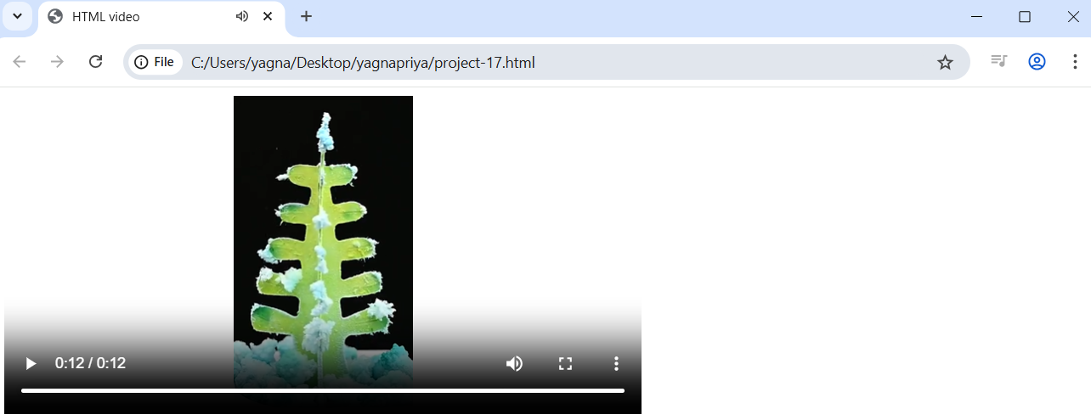

**Project-18**

**Title: Design a web page by demonstrating the usage of HTML. Audio Tag.**

**Source Code:**

<!DOCTYPE html>

<html>

    <head>

        <title>

            HTML audoi

        </title>

        <body>

            <audio src ="Music.mp3" controls></audio>

        </body>

    </head>

</html>

**Output:**

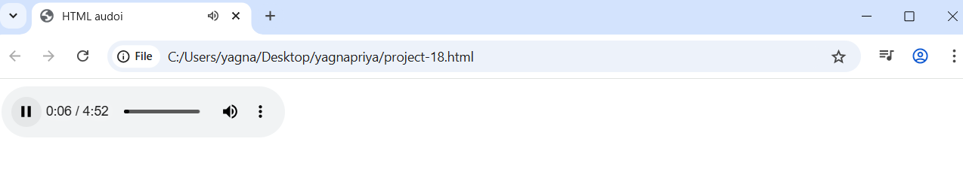

**Project-19**

**Title: Design a web page by demonstrating the usage of Div Tag:**

**Source Code:**

<!DOCTYPE html>

<html>

<head>

    <title>  Div container Example </title>/head>

<body>

    <div style="border: 10px solid black; padding: 10px;">

        <h2>Div container</h2>

        <p>This is a paragraph inside a div container</p>

    </div>

</body>

</html>

**Output:**

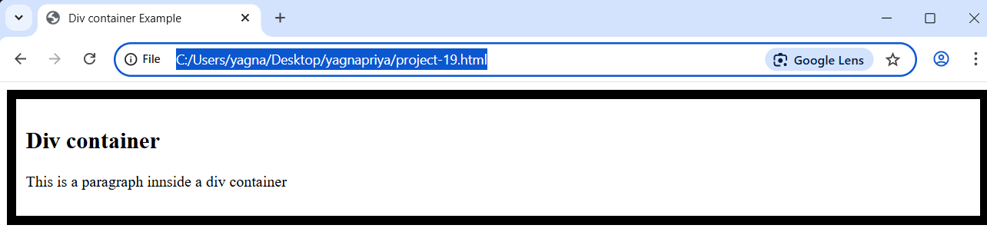

**Project-20**

**Title: Design a web page by demonstrating the usage of HTML Marquee Tag.**

**Source Code:**

<!DOCTYPE html>

<html>

<head>

    <title>  Marquee Tag Example </title>

</head>

<body>

    <h2>Scrolling Text Example</h2>

     <marquee>Welcome to our website! Stay tuned for updates. </marquee>

</body>

</html>

**Output:**

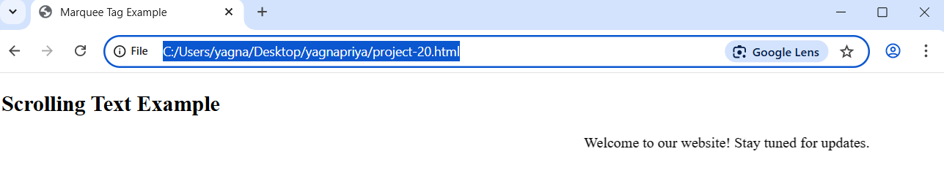

**Project-21**

**Title: Design a web page by demonstrating the usage of HTML Marquee Tag.**

**Source Code:**

<!DOCTYPE html>

<html>

<head>

    <title>  Marquee Tag </title>

</head>

<body>

   <h1>MARQUEE TAG</h1>

   <marquee direction="right" bgcolor="lightblue" width="50%" height="50px">Scrolling Left to Right</marquee>

   <marquee direction="left" bgcolor="lightgreen" width="80%" height="50px">Scrolling Right to Left</marquee>

   <marquee direction="down" bgcolor="lightcoral" width="50%" height="200px">

   <img src="india.jpg" alt="Scrolling Image1"> </marquee>

   <marquee direction="up" bgcolor="lightyellow" width="50%" height="200px">

    <img src="india.jpg" alt="Scrolling Image2"> </marquee>

</body>

</html>

**Output:**

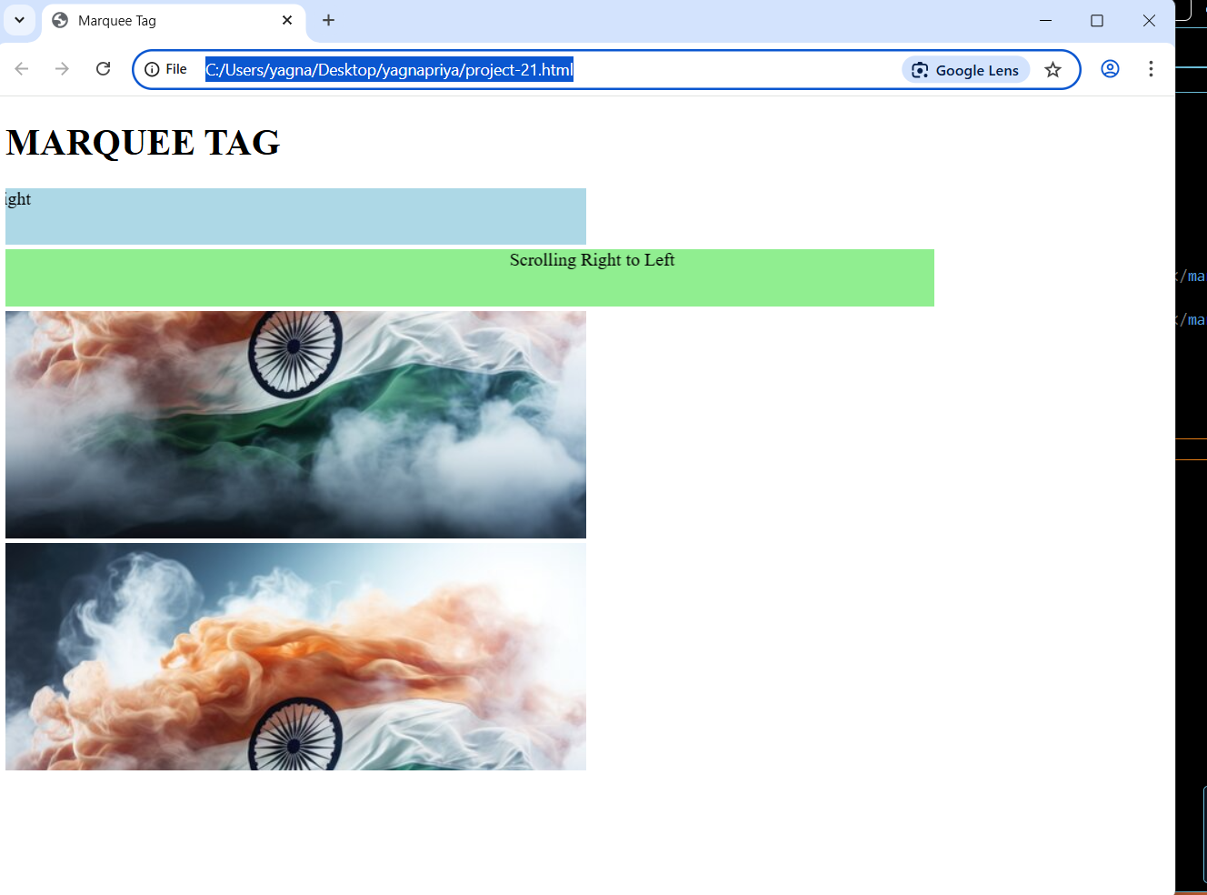

**Project-22**

**Title: Design a web page by demonstrating the usage of HTML Marquee Tag.**

**Source Code:**

<!DOCTYPE html>

<html>

    <head>

        <title>Image Background</title>

    </head>

    <body background="india.jpg">

        <p>Laptops are poratable computers designed to be carried around, making them ideal for use  various locations like home, office, or on the go. They are powered by batteries,</p>

    </body>

</html>

**Output:**

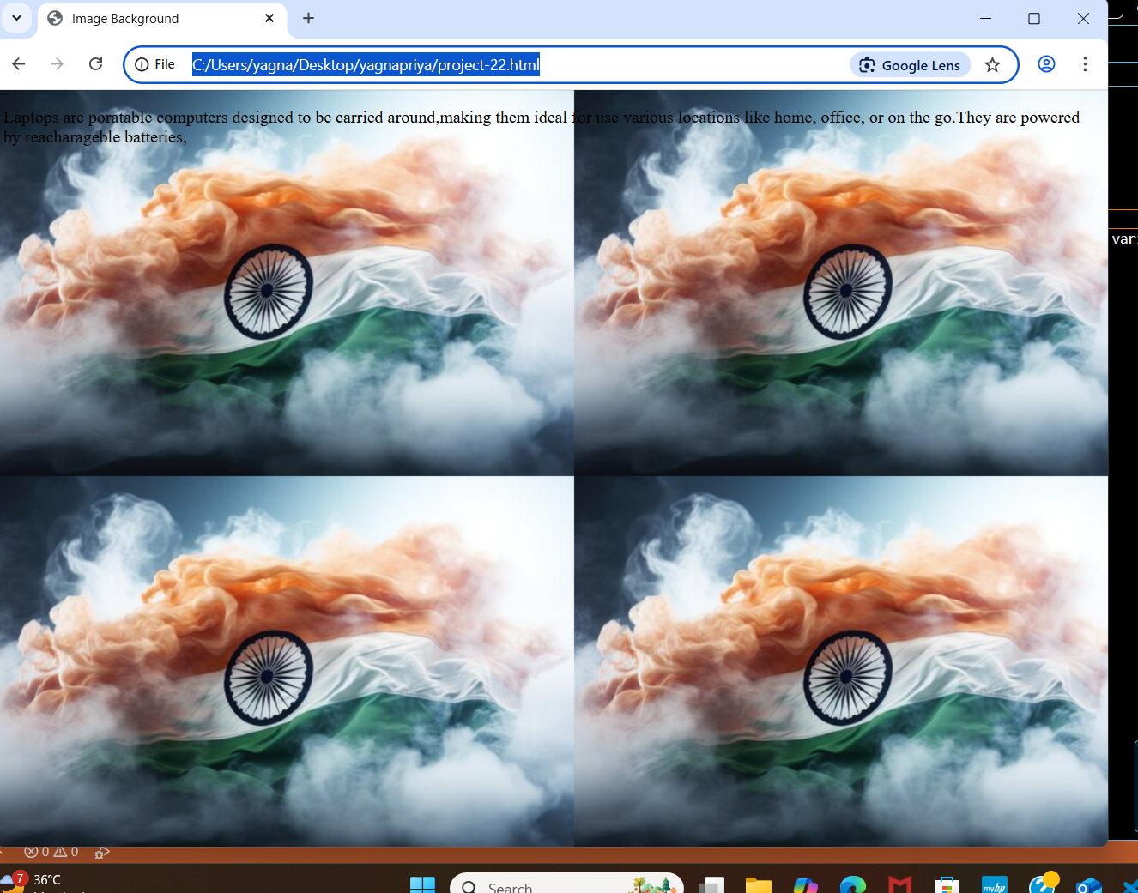

**Project-23**

**Title: Design a web page by demonstrating the usage of HTML Rowspan and colspan attributes in a table:**

**Source Code:**

<!DOCTYPE html>

<html>

    <head>

        <title> Table with Colspan and Rowspan</title>

    </head>

    <body>

        <h2>Table Example with Colspan and Rowspam</h2>

        <p><strong>Collspan:</strong>This header spans across two columns.</p>

        <table border="1">

            <tr>

                <th colspan="2">Name</th>

                <th>Age</th>

            </tr>

            <tr>

                <td>yagna</td>

                <td>priya</td>

                <td>19</td>

           </tr>

           <tr>

            <td>bhagya</td>

            <td>laxmi</td>

            <td>18</td>

           </tr>

        </table>

        <br>

        <p><strong>Rowspan:</strong>This cell spans across two rows</p>

        <table border="1">

            <tr>

                <th>Name</th>

                <th>Age</th>

                <th rowspan="2">city</th>

            </tr>

            <tr>

                <td>likki</td>

                <td>20</td>

            </tr>

            <tr>

                <td>keerthi</td>

                <td>22</td>

                <td>srikakulam</td>

            </tr>

        </table>

    </body>

</html>

**Output:**

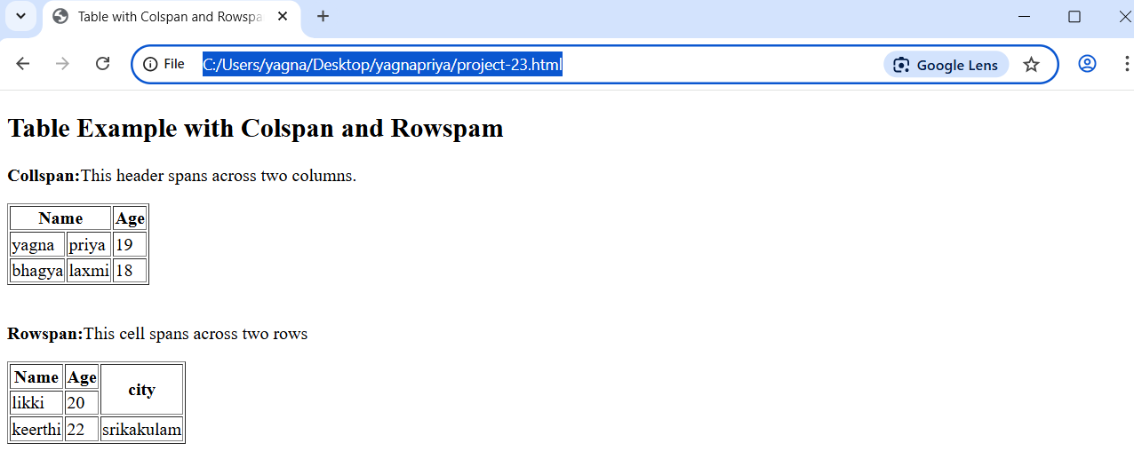

**Project-24**

**Title: Design create a web page by demonstrating the usage of HTML the <b> (bold) tag.**

**Source Code:**

<!DOCTYPE html>

<html>

    <head>

        <title><b>-Bold</title>

    </head>

    <body>

        <p>This is <b>bold</b>word.</p>

    </body>

</html>

**Output:**

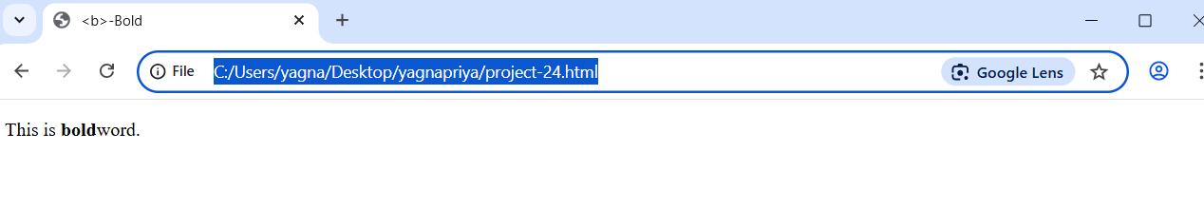

**Project-25**

**Title: Create a web page demonstrating the use of the <strong> tag.**

**Source Code:**

<!DOCTYPE html>

<html>

    <head>

        <title><strong>- Strong importance</title>

    </head>

    <body>

        <p>This is <strong>important </strong>text.</p>

    </body>

</html>

**Output:**

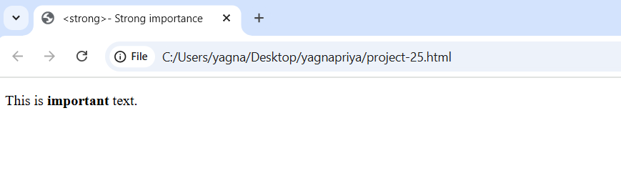

**Project-26**

**Title: Create a web page demonstrating the use of the <i> tag.**

**Source Code:**

<!DOCTYPE html>

<html>

    <head>

        <title><i>-Italic Text</title>

    </head>

    <body>

        <p>This is an <i>italic </i>word.</p>

    </body>

</html>

**Output:**

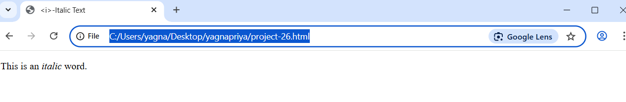

**Project-27**

**Title: Create a web page demonstrating the use of the <em> tag.**

**Source Code:**

<!DOCTYPE html>

<html>

    <head>

        <title><em>-Emphasized text</title>

    </head>

    <body>

        <p>This is <em>emphasized</em> text</p>

    </body>

</html>

**Output:**

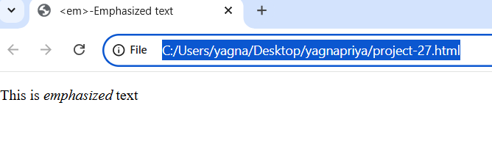

**Project-28**

**Title: Create a web page demonstrating the use of the <u> tag.**

**Source Code:**

<!DOCTYPE html>

<html>

    <head>

        <title><u>-Underlined Text</title>

    </head>

    <body>

        <p>This is an <u>Underlined</u> word.</p>

    </body>

</html>

**Output:**

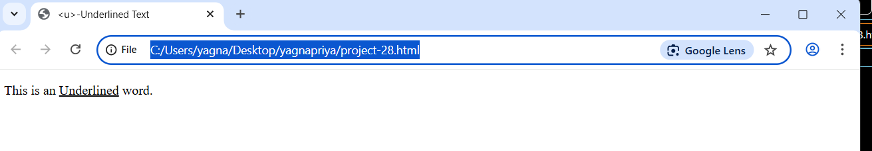

**Project-29**

**Title: Create a web page demonstrating the use of the <mark> tag.**

**Source Code:**

<!DOCTYPE html>

<html>

    <head>

        <title><mark>-Highlighted Text</title>

    </head>

    <body>

        <p>This is a <mark>highlighted</mark> word.</p>

    </body>

</html>

**Output:**

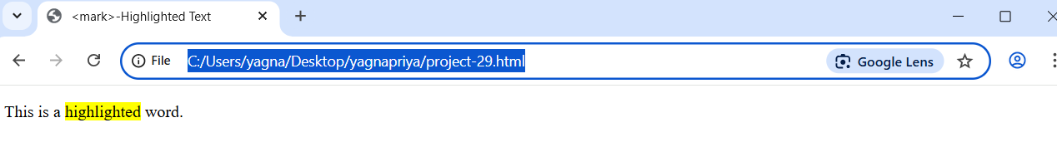

**Project-30**

**Title: Create a web page demonstrating the use of the <small> tag.**

**Source Code:**

<!DOCTYPE html>

<html>

    <head>

        <title><small>-Smaller Text</title>

    </head>

    <body>

        <p>This is a <small>smaller</small> text.</p>

    </body>

</html>

**Output:**

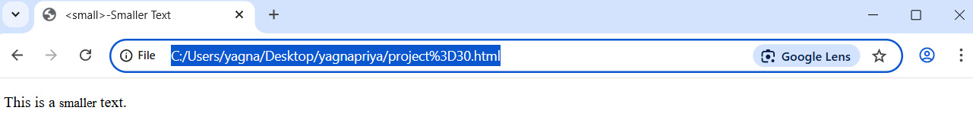

**Project-31**

**Title: Design a web page to open an external link.**

**Source Code:**

<!DOCTYPE html>

<html>

    <head>

        <title>External Link Example</title>

    </head>

    <body>

        <h2>External Website Link</h2>

        <p>

            Click the link below

        </p>

        <a href="https://www.google.com/webhp?hl=en&sa=X&sqi=2&ved=0ahUKEwii3qrAjaiNAxUTXGwGHRX_J-sQPAgI" target="_blank"> Visit google</a>

    </body>

</html>

**Output:**

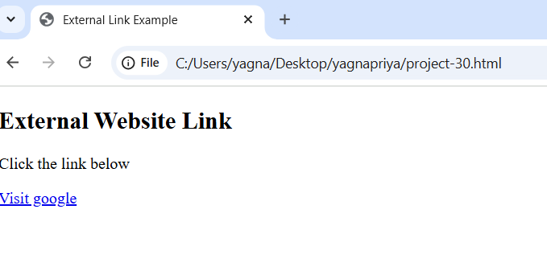

**Project-32**

**Title: Design a web page to open an mailto link**

**Source Code:**

<!DOCTYPE html>

<html>

    <head>

        <title>Send Email</title>

    </head>

    <body>

        <h2>Contact us</h2>

        <p>

            Click the link below to send us an email:

        </p>

        <a href="yagnapriyakanithi@gmail.com">Send Email</a>

    </body>

</html>

**Output:**

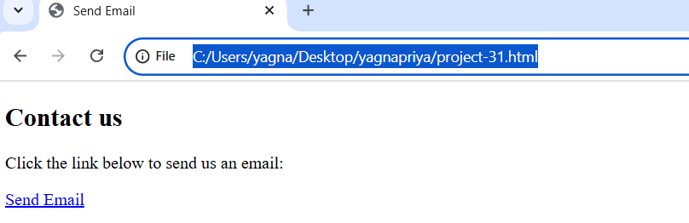

**Project-33**

**Title: Phone number link:**

**Source Code:**

<!DOCTYPE html>

<html>

    <head>

        <title>Call us</title>

    </head>

    <body>

        <h2>Contact us</h2>

        <p>

            Click the link below to call us:

        </p>

        <a href="tel:9494163331"> Call 123-456</a>

    </body>

</html>

**Output:**

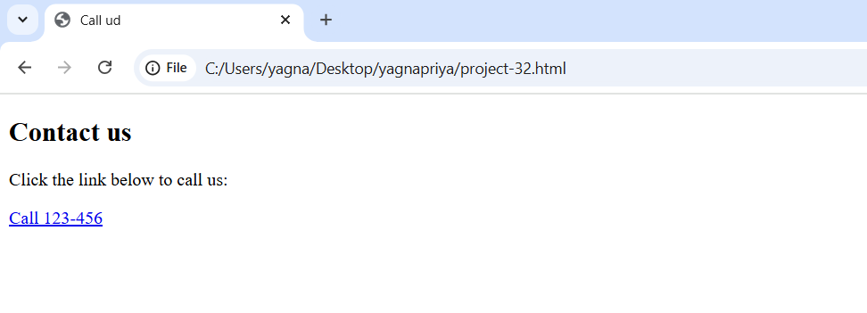

**Project-34**

**Title: Section on the same page:**

**Source Code:**

<!DOCTYPE html>

<html>

    <head>

        <title>Section Navigation </title>

    </head>

    <body>

        <h2>Welcome to our website</h2>

        <p>Click the link below to go to section 1:</p>

        <a href="#section 1">Go to Section 1</a>

        <div style="height: 800px;"><!--Added for Srolling effect-->

        <p>Scroll down to see the sections</p>

        </div>

        <h2 id="section 1">Section</h2>

        <p>This is section 1. You Have jumped to this part of the page!</p>

        <a href="#top">Go Back to Top </a>

    </body>

</html>

**Output:**

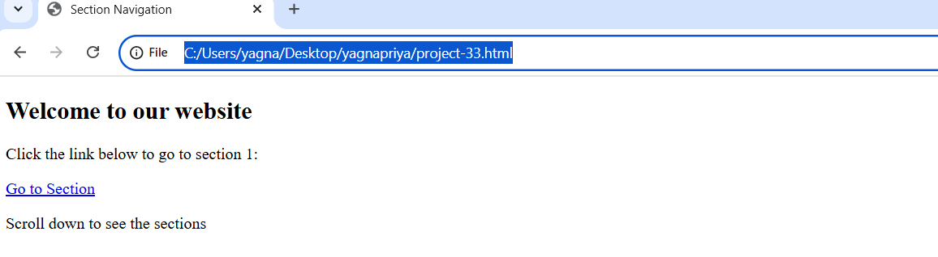

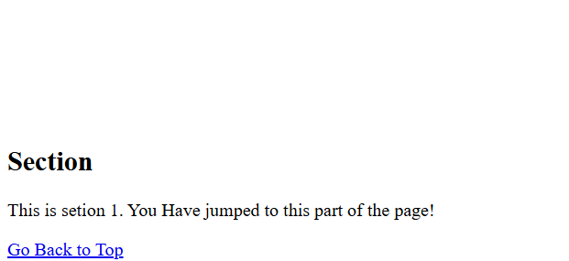

**Project-34**

**Title: Design a web page by demonstrating the usage of Form Tag.**

**Source Code:**

<!DOCTYPE html>

<html>

    <head>

        <title>

            Simple forms

        </title>

    </head>

    <body>

        <form>

            Name:<input type="text"><br><br>

            Email:<input type="text"><br><br>

            <input type="submit" value="Submit">

        </form>

    </body>

</html>

**Output:**

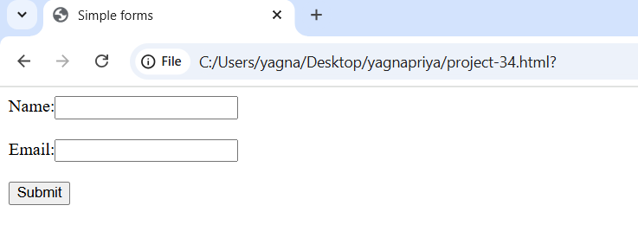

**Project-35**

**Title: Design a web page by demonstrating the usage of Form Tag.**

**Source Code:**

<!DOCTYPE html>

<html>

    <head>

        <title>Radio Button Examplle</title>

    </head>

    <body>

        <h2>Selecct your gender</h2>

        <form>

            <input type="radio" id="male" name="gender" value="male">

            <label for="male">MALE</label><br>

            <input type="radio" id="female" name="gender" value="female">

            <label for="female">FEMALE</label><br>

            <input type="radio" id="other" name="gender" value="other">

            <label for="other">OTHER</label>

</form>

    </body>

</html>

**Output:**

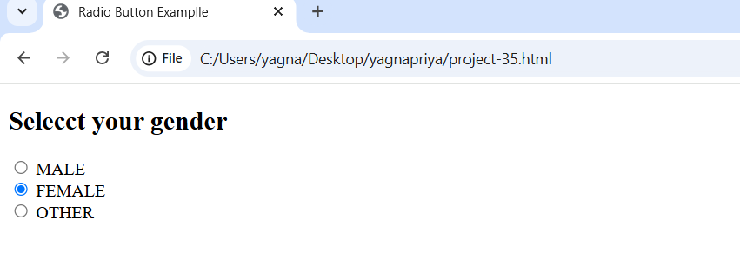

**Project-36**

**Title: Design a web page by demonstrating the usage of Form Tag.**

**Source Code:**

<!DOCTYPE html>

<html>

    <head>

        <title>Check box example</title>

    </head>

    <body>

        <h2>Selecct your skills</h2>

        <form>

            <input type="checkbox" id="html" name="skills" value="HTML">

            <label for="html">HTML</label><br>

            <input type="checkbox" id="css" name="skills" value="CSS">

             <label for="css">CSS</label><br>

            <input type="checkbox" id="js" name="skills" value=" javaScript">

            <label type="js">JavaScript</label>

        </form>

    </body>

</html>

**Output:**

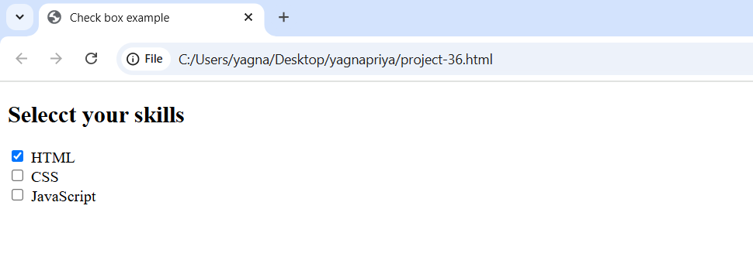

**Project-37**

**Title: Design a web page by demonstrating the usage of Form Tag.**

**Source Code:**

<!DOCTYPE html>

<html>

    <head>

        <title>

            Dropdown Example

        </title>

    </head>

    <body>

        <h2>Select Your City</h2>

        <form>

            <label for="city">CITY:</label>

            <select id="city" name="city">

                <option value="VIzag">VIZAG</option>

                <option value="Hyderabad">HYDERABAD</option>

                <option value="Srikakulam">SRIKAKULAM</option>

                <option value="Tirupati">TIRUPATI</option>

            </select>

        </form>

    </body>

</html>

**Output:**

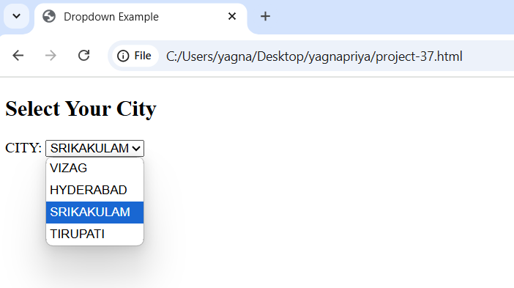

**Project-38**

**Title: Design a web page by demonstrating the usage of Form Tag.**

**Source Code:**

<!DOCTYPE html>

<html>

    <head>

        <title>Textarea Example</title>

    </head>

    <body>

        <h2>Leave a Comment</h2>

        <form>

            <label for="comment">Your Comment</label><br>

            <textarea id="comment" name="comment" rows="5" cols="30"></textarea>

        </form>

    </body>

</html>

**Output:** 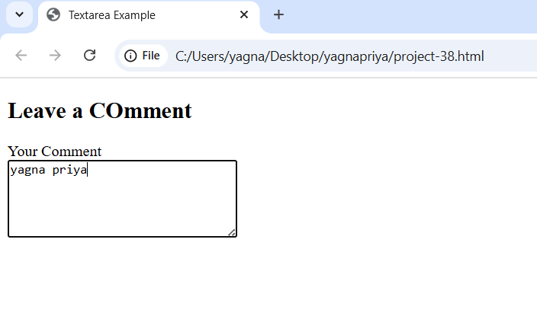

**Project-39**

**Title: Design a web page by demonstrating the usage of Form Tag.**

**Source Code:**

<!DOCTYPE html>

<html>

    <head>

        <title>Button Example</title>

    </head>

    <body>

        <h2>Click a Button</h2>

        <form>

            <button type="submit">Submit</button>

            <button type="reset">Reset</button>

            <button type="button" onclick="alert<you clicked me!)">Click Me</button>

        </form>

    </body>

</html>

**Output:** 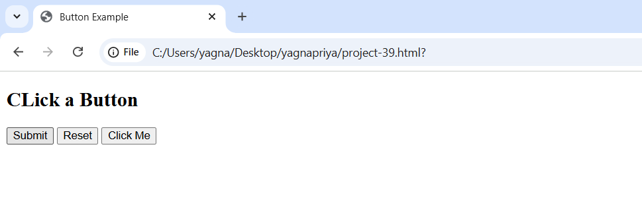

**Project-40**

**Title: Design a web page by demonstrating the usage of <sup> Tag.**

**Source Code:**

<!DOCTYPE html>

<html>

    <head>

        <title>Superscript Example</title>

    </head>

    <body>

        <h2>Using the sup tag</h2>

        <p>The area of square is 25cm <sup>2</sup>.</p>

    </body>

</html>

**Output:**

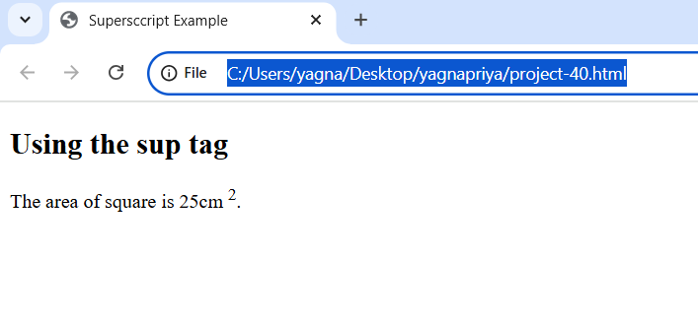

**Project-41**

**Title: Design a web page by demonstrating the usage of <sub> Tag.**

**Source Code:**

<!DOCTYPE html>

<html>

    <head>

        <title>Superscript Example</title>

    </head>

    <body>

        <h2>Using the sup tag</h2>

        <p>Water's chemical formula is H<sub>2</sub>O and carbon dioxide is CO<sub>2</sub>.</p>

    </body>

</html>

**Output:**

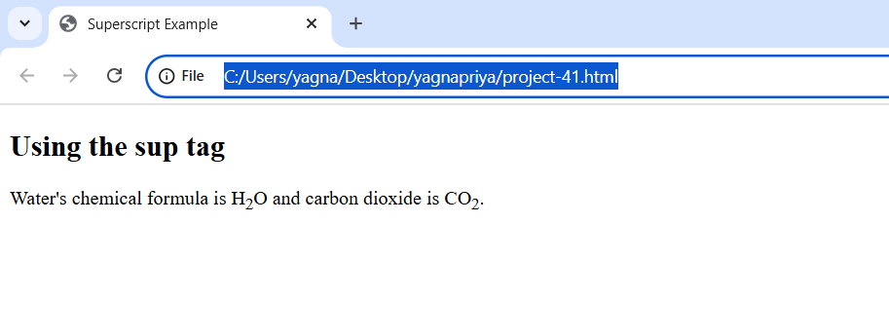

**Project-42**

**Title: Design a web page by demonstrating the usage of ‘<del>’ Tag.**

**Source Code:**

<!DOCTYPE html>

<html>

    <head>

        <title>Deleted Text Example</title>

    </head>

    <body>

        <h2>Using the del tag</h2>

        <p>The original price was <del>₹500</del>now it's ₹300!</p>

    </body>

</html>

**Output:**

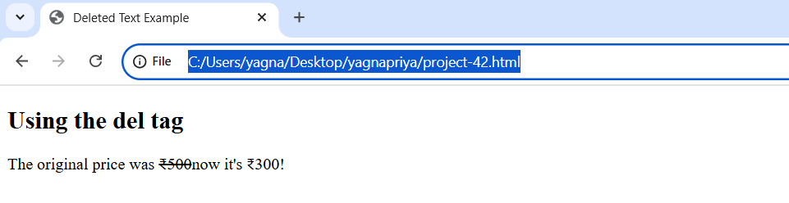

**Project-43**

**Title: Design a web page by demonstrating the usage of ‘<ins>’ Tag.**

**Source Code:**

<!DOCTYPE html>

<html>

    <head>

        <title>Inserted Text Example</title>

    </head>

    <body>

        <h2>Using the ins tag</h2>

        <p>

            We have updated our policy to include <ins>free home delivery </ins> for all orders above ₹300.

        </p>

    </body>

</html>

**Output:**

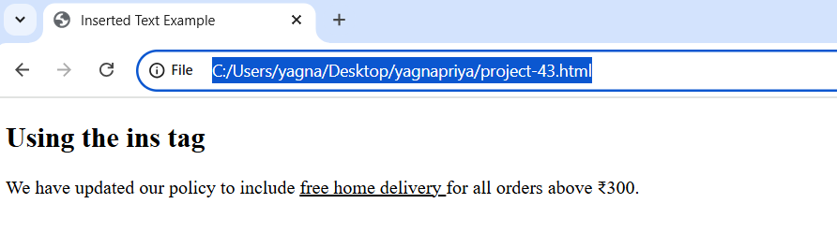

**Project-44**

**Title: Design a web page by demonstrating the usage of ‘<q>’ Tag.**

**Source Code:**

<!DOCTYPE html>

<html>

    <head>

        <title>Quotation Example</title>

    </head>

    <body>

        <h2>Using the q tag</h2>

        <p>

            He said, <q> Practice makes perfect</q>

        </p>

    </body>

</html>

**Output:**

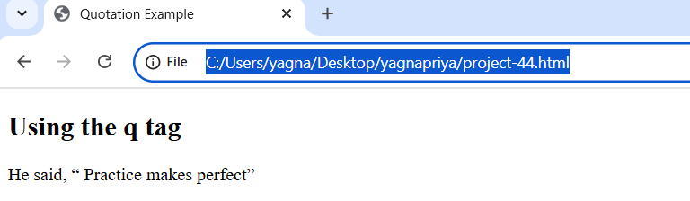

**Project-45**

**Title: Design a web page by demonstrating the usage of ‘<kbd>’ Tag.**

**Source Code:**

<!DOCTYPE html>

<html>

    <head>

        <title>Keyboard Input Example</title>

    </head>

    <body>

        <h2>Using the kbd tag</h2>

        <p>

            TO copy text, press <kbd>Ctrl</kbd> + <kbd>C</kbd>.

        </p>

    </body>

</html>

**Output:**

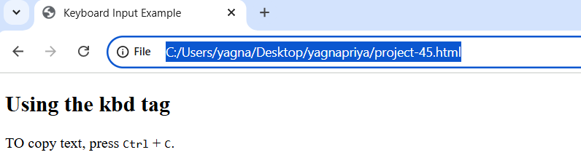

**Project-46**

**Title: Design a web page by demonstrating the usage of ‘<fieldset>’ Tag.**

**Source Code:**

<!DOCTYPE html>

<html>

    <head>

        <title>Fieldset Example</title>

    </head>

    <body>

        <h2>Using the fieldset tag</h2>

        <form>

        <fieldset>

            <h3>Delivery Address</h3>

            Full name: <input type="text"><br><br>

            Mobile name: <input type="tel"><br><br>

            Adress: <textarea rows="3" cols="30" placeholder="street, City, PIN"></textarea>

        </fieldset>

        </form>

    </body>

</html>

**Output:**

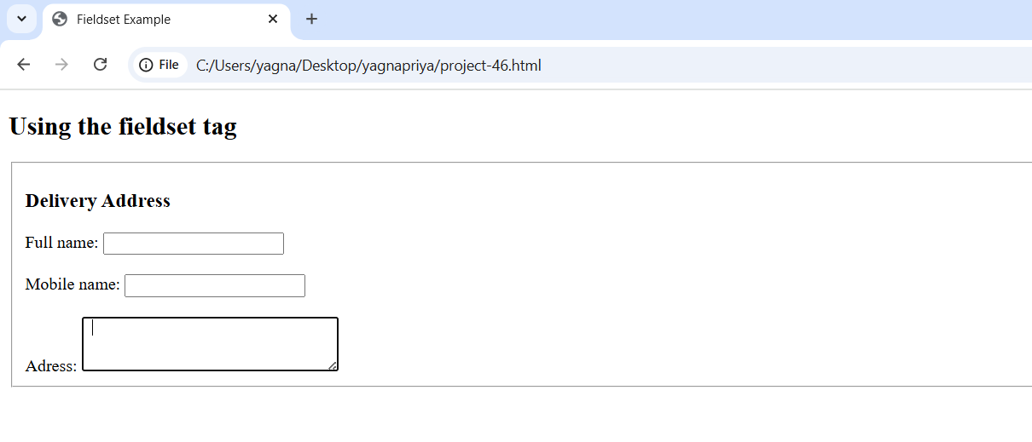

**Project-47**

**Title: Design a web page by demonstrating the usage of ‘<legend>’ Tag.**

**Source Code:**

<!DOCTYPE html>

<html>

    <head>

        <title>Legend Example</title>

    </head>

    <body>

        <h2>Using the legend tag</h2>

        <form>

        <fieldset>

            <legend><label for="pay">Payment Method</label></legend>

            <input type="radio" name="pay" value="upi" checked> UPI <br>

            <input type="radio" name="pay" value="credit"> Credit Card <br>

            <input type="radio" name="pay" value="cod"> Cash on delivery

        </fieldset>

        </form>

    </body>

</html>

**Output:**

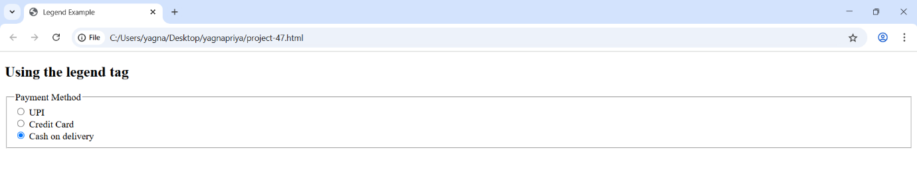

**Project-48**

**Title: Design a web page by demonstrating the usage of ‘<frameset>’ Tag.**

**Source Code:**

<!DOCTYPE html>

<html>

    <head>

        <title>Frameset Example</title>

    </head>

    <frameset cols="50%,50%">

        <frame src="https://www.wikipedia.org"></frame>

        <frame src="https://www.example.com"></frame>

    </frameset>

</html>

**Output:**

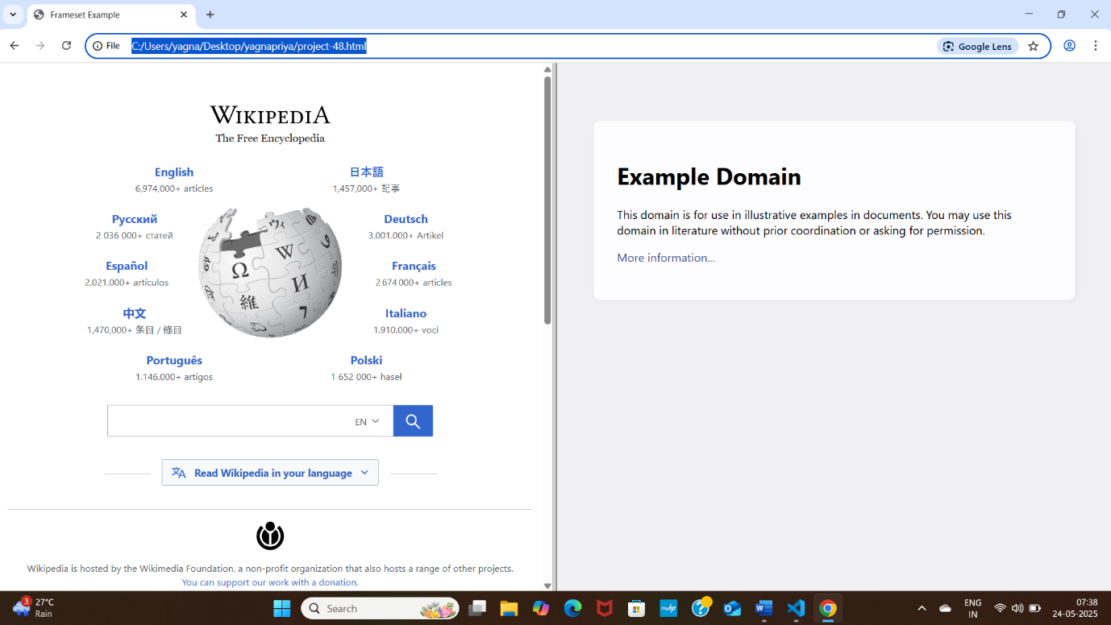

**Project-49**

**Title: Design a web page by demonstrating the usage of ‘cols’ attribute in ‘<frameset>’.**

**Source Code:**

<!DOCTYPE html>

<html>

    <head>

        <title>Frameset with columns Example</title>

    </head>

    <frameset cols="30%,70%">

        <frame src="https://www.wikipedia.org"></frame>

        <frame src="https://www.example.com"></frame>

    </frameset>

</html>

**Output:**

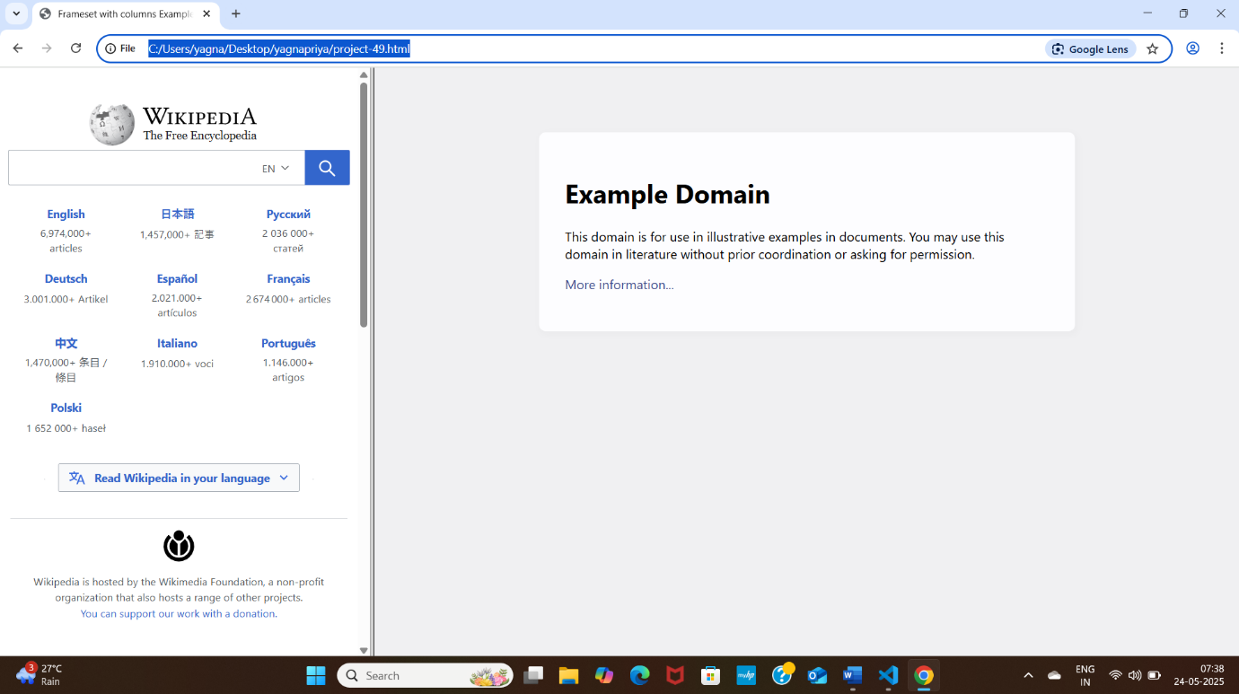

**Project-50**

**Title: Design a web page by demonstrating the usage of the ‘rows’ attribute in ‘<frameset>’.**

**Source Code:**

<!DOCTYPE html>

<html>

    <head>

        <title>Frameset with rows Example</title>

    </head>

    <frameset cols="40%,60%">

        <frame src="https://www.wikipedia.org"></frame>

        <frame src="https://www.example.com"></frame>

    </frameset>

</html>

**Output:**

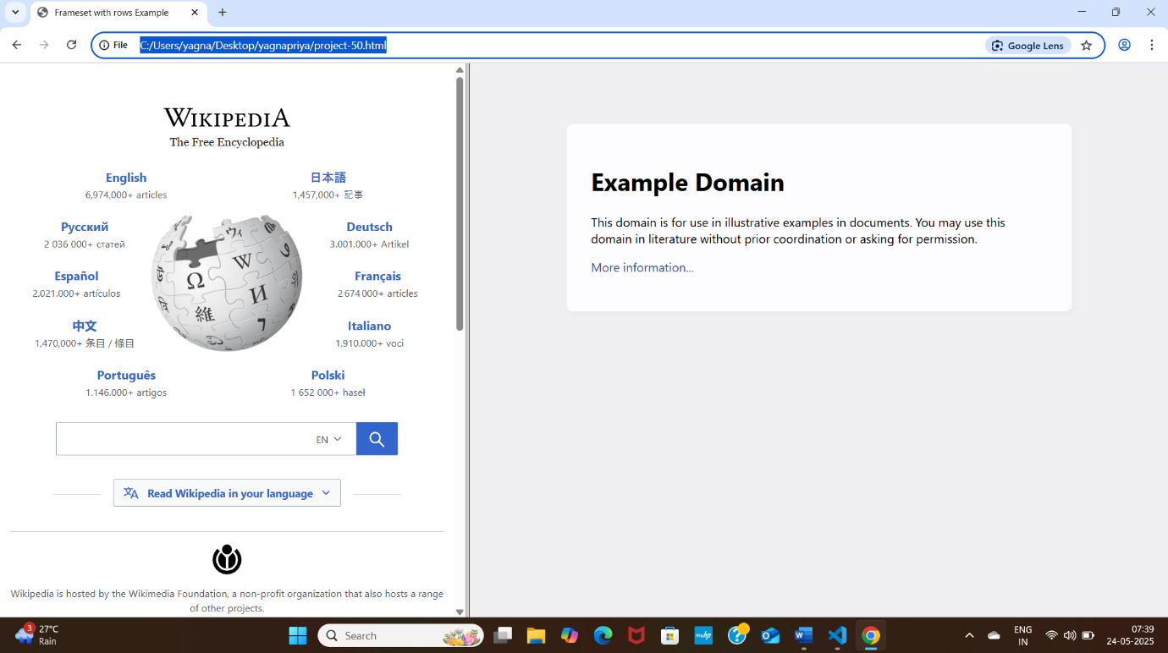

**Project-51**

**Title: Design a web page by demonstrating the usage of the ‘frameborder’ attribute in ‘<frameset>’.**

**Source Code:**

<!DOCTYPE html>

<html>

    <head>

        <title>Frameset without Borders</title>

    </head>

    <frameset cols="50%,50%" frameborder="0">

        <frame src="https://www.wikipedia.org"></frame>

        <frame src="https://www.example.com"></frame>

    </frameset>

</html>

**Output:**

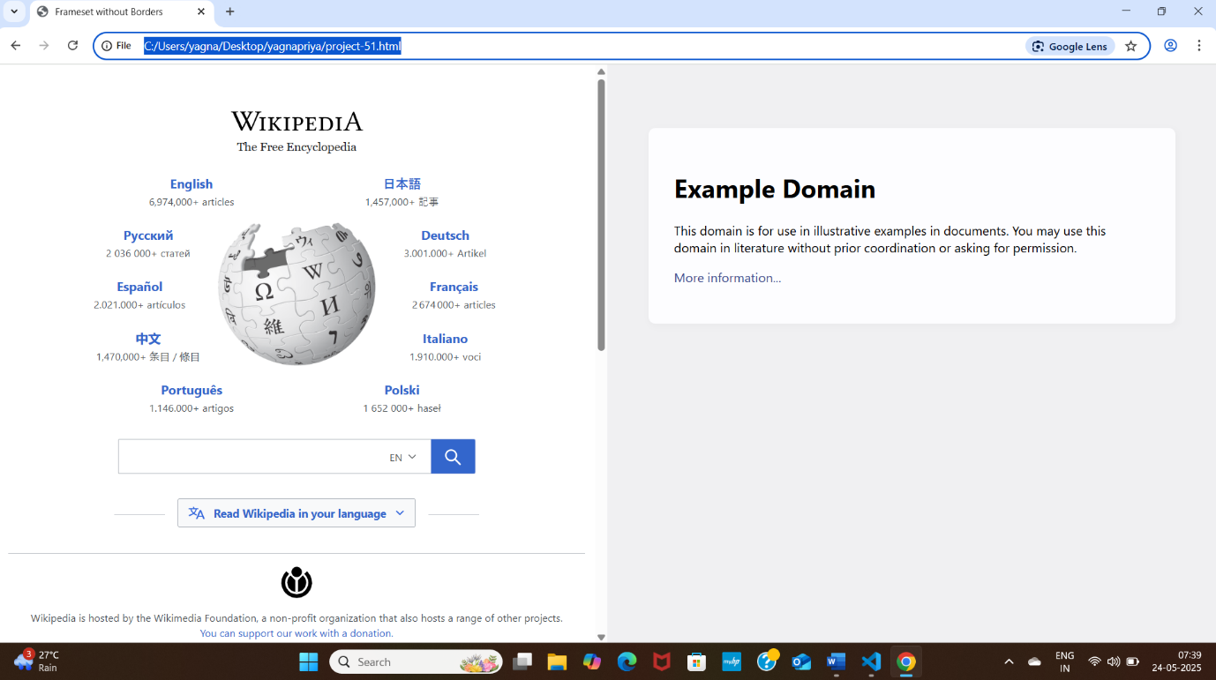

**Project-52**

**Title: Design a web page by demonstrating the usage of the ‘border’ attribute in ‘<frameset>’.**

**Source Code:**

<!DOCTYPE html>

<html>

    <head>

        <title>Frameset without Custom Borders</title>

    </head>

    <frameset cols="50%,50%" border="5">

        <frame src="https://www.wikipedia.org"></frame>

        <frame src="https://www.example.com"></frame>

    </frameset>

</html>

**Output:**

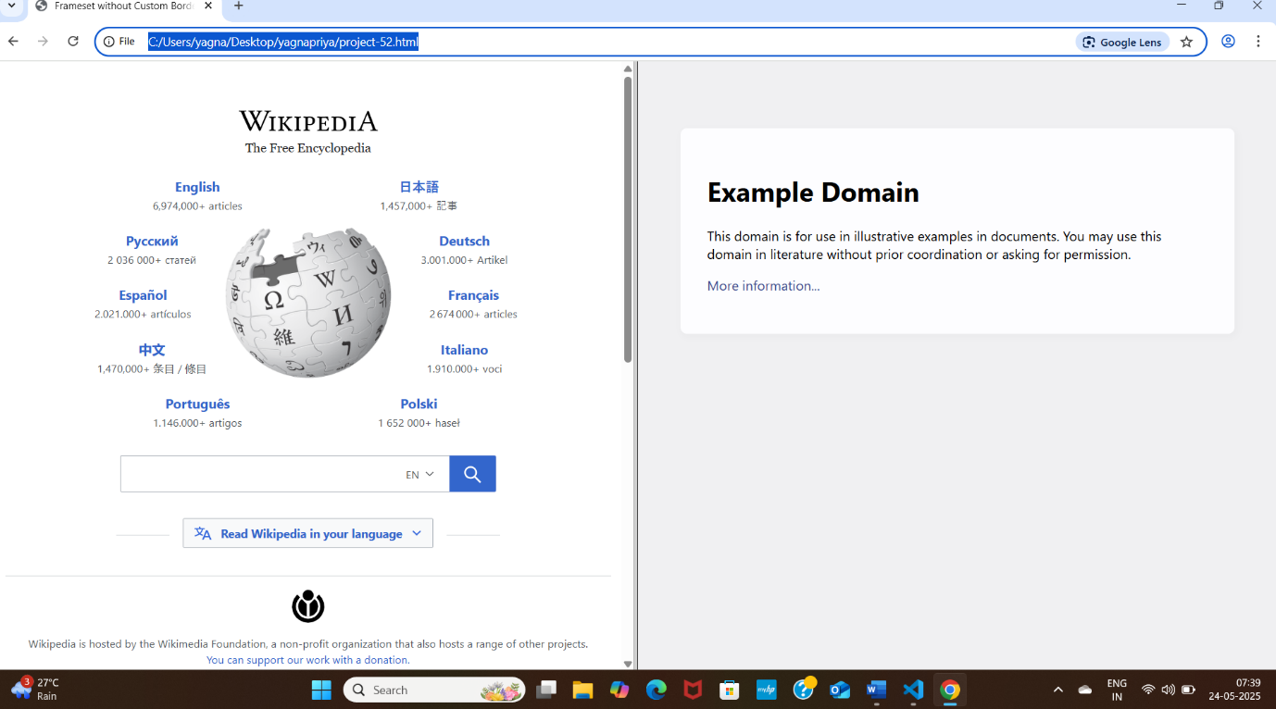

**Project-53**

**Title: Design a web page by demonstrating the usage of the ‘noresize’ attribute in ‘<frame>’.**

**Source Code:**

<!DOCTYPE html>

<html>

    <head>

        <title>Frameset without no resize</title>

    </head>

    <frameset cols="50%,50%">

        <frame src="https://www.wikipedia.org"></frame>

        <frame src="https://www.example.com"></frame>

    </frameset>

</html>

**Output:**

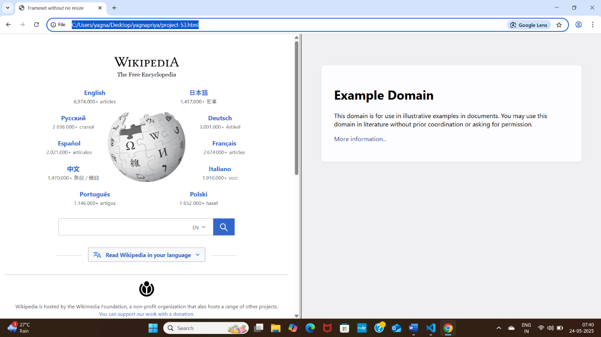

**Project-54**

**Title: Design a web page by demonstrating the usage of the ‘<header>’ tag.**

**Source Course:**

<!DOCTYPE html>

<html>

    <head>

        <title>Header Example</title>

    </head>

    <body>

        <header>

        <h1>My Travel Blog</h1>

        <nav>

            <a href="#home">Home</a> |

            <a href="#destinations">Destinations</a> |

            <a href="#contact">Contact</a> |

        </nav>

        </header>

    </body>

</html>

**Output:**

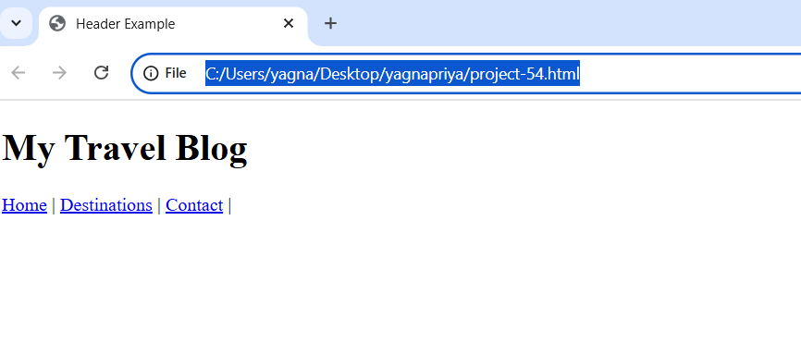

**Project-55**

**Title: Design a web page by demonstrating the usage of the ‘<nav>’ tag.**

**Source Code:**

<!DOCTYPE html>

<html>

    <head>

        <title>Nav Example</title>

    </head>

    <body>

        <nav>

            <ul>

                <li><a href="#home">Home</a></li>

                <li><a href="#services">Services</a></li>

                <li><a href="#blog">Blog</a></li>

            </ul>

        </nav>

    </body>

</html>

**Output:**

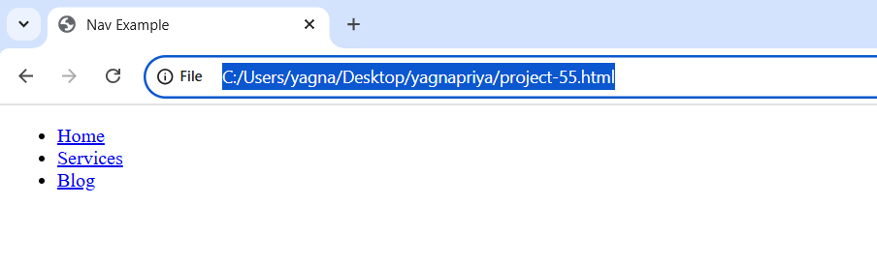

**Project-56**

**Title: Design a web page by demonstrating the usage of the ‘<main>’ tag.**

**Source Code:**

<html>

    <head>

        <title>Main Tag Example</title>

    </head>

    <body>

        <main>

            <h2>Today's Weather Update</h2>

            <p>It's sunny with a high of 32 degrees and low humidity across coastal regions.</p>

        </main>

    </body>

</html>

**Output:**

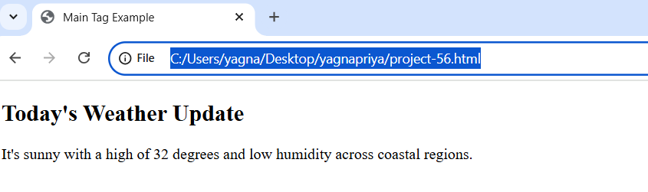

**Project-57**

**Title: Design a web page by demonstrating the usage of the ‘<article>’ tag.**

**Source Code:**

<!DOCTYPE html>

<html>

    <head>

        <title>article Example</title>

    </head>

    <body>

        <article>

            <h2>Top 5 Budget Travel Destinations</h2>

            <p>Explore places like Bali, Vietnam, and georgla without bracking the bank!</p>

        </article>

    </body>

</html>

**Output:**

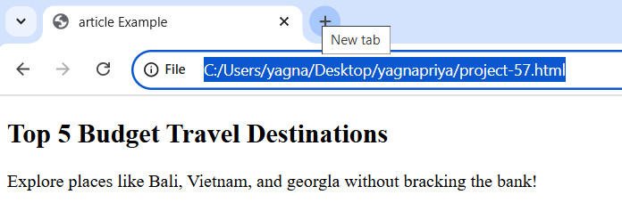

**Project-58**

**Title: Design a web page by demonstrating the usage of the ‘<aside>’ tag.**

**Source Code:**

<!DOCTYPE html>

<html>

    <head>

        <title>Section Example</title>

    </head>

    <body>

        <main>

            <h2>How to Bake a cake</h2>

            <p>Follow these simple steps to make a delicious chocolate cake.</p>

        </main>

        <aside>

            <h3>Pro Tip</h3>

            <p>Always use fresh eggs for better results!</p>

        </aside>

    </body>

</html>

**Output:**

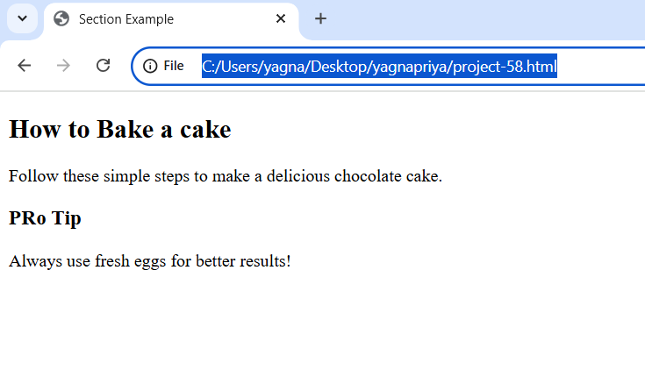

**Project-59**

**Title: Design a web page by demonstrating the usage of the ‘<section>’ tag**

**Source Code:**

<!DOCTYPE html>

<html>

    <head>

        <title>Section Example</title>

    </head>

    <body>

        <section>

            <h2>About our Company</h2>

            <p>We specialize in eco-friendly home solutions.</p>

        </section>

    </body>

</html>

**Output:**

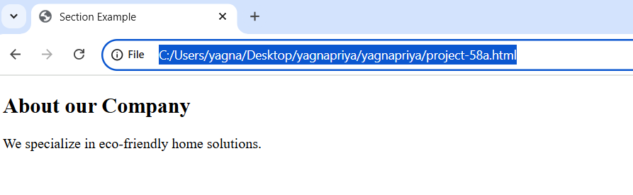

**Project-60**

**Title: Design a web page by demonstrating the usage of the ‘<footer>’ tag**

**Source Code:**

<!DOCTYPE html>

<html>

    <head>

        <title>Footer Example</title>

    </head>

    <body>

        <footer>

            <p>&copy;2025 priya. All rights reserved.</p>

            <p>Contact: yagnapriyakanithi@gmail.com</p>

        </footer>

    </body>

</html>

**Output:**

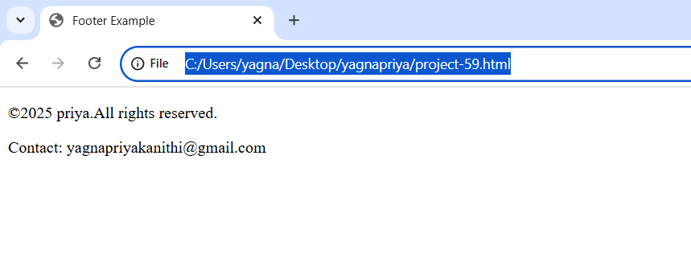

**Project-61**

**Title: Design a web page demonstrating the usage of the <figure> and <figcaption> tags.**

**Source Code:**

<!DOCTYPE html>

<html>

    <head>

        <title>Figure and Figcaption Example</title>

    </head>

    <body>

        <h1>My Photo Gallery</h1>

        <figure>

            <img src="Image.jpg" alt="this is a picture" width="400">

            <figcaption>

                 It is cartooon, which come disney channel. This cartoon is called as Doremon.

            </figcaption>

        </figure>

    </body>

</html>

**Output:**

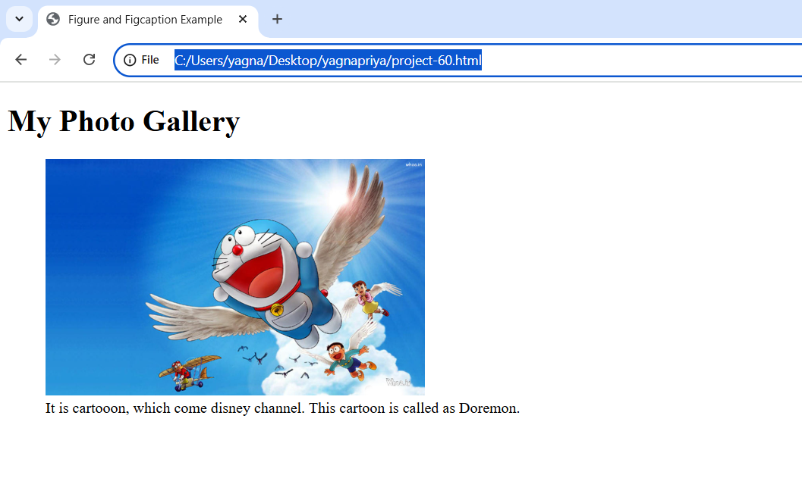

**Project-62**

**Title: Design a web page implementing Inline CSS.**

**Source Code:**

<!DOCTYPE html>

<html>

    <head><title>Inline CSS Example</title></head>

    <body>

        <h1 style="color: blue; font-size: 24px; text-align: center;">Welcome to Inline CSS</h1>

        <p style="color:green; font-size: 16px;">This paragraph is styled with inline CSS</p>

    </body>

</html>

**Output:**

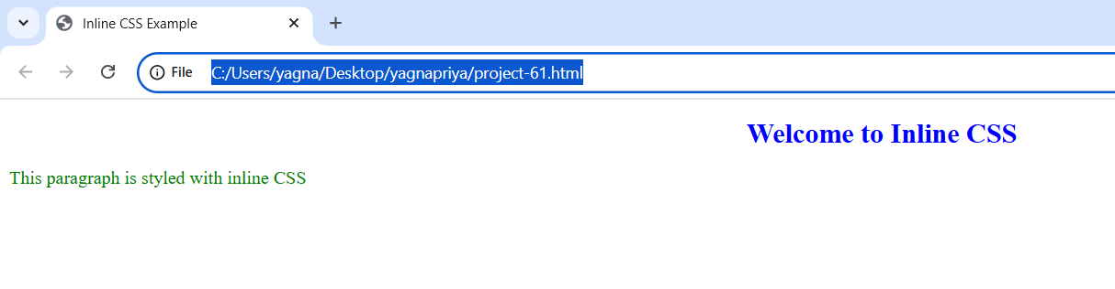

**Project-63**

**Title: Design a web page implementing internal CSS.**

**Source Code:**

<!DOCTYPE html>

<html>

    <head>

        <title>Internal CSS Example</title>

        <style>

            body {

              background-color: lightblue;

            }

            h1 {

                color: navy;

            }

            p {

                color: red;

                font-size: 18px;

            }

        </style>

    </head>

    <body>

        <h1>Welcome to Internal CSS</h1>

        <p>This paragraph is styled with Internal CSS </p>

        </body>

</html>

**Output:**

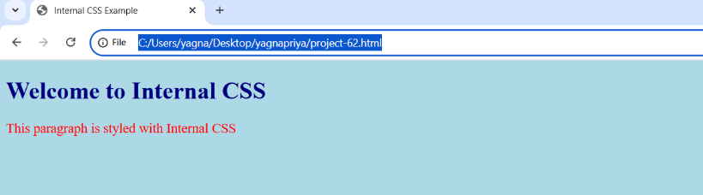

**Project-64**

**Title: Design a web page implementing External CSS.**

**Source Code:**

<!DOCTYPE html>

<html>

    <head>

        <title>External CSS Example</title>

        <link rel="stylesheet" href="External CSS.css">

    </head>

    <body>

        <h1>Welcome to External CSS!</h1>

        <p>This paragraph is styled with external CSS.</p>

        <button>Click Me</button>

    </body>

</html>

*CSS Code(External CSS.css):*

h1 {

    color: blue;

    font-size: 24px ;

    text-align: center;

}

p {

    color: green;

    font-size: 16px;

}

button {

    background-color: orange;

    color: white;

    padding: 10px;

    border: none;

    cursor: pointer;

}

**Output:**

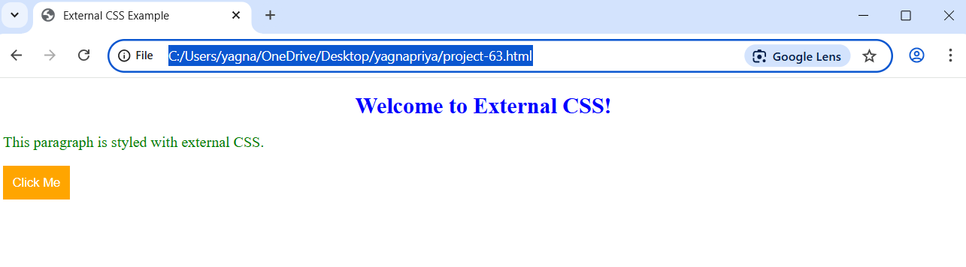

**Project-65**

**Title: Design a web page implementing the usage of CSS background property.**

**Source Code:**

<!DOCTYPE html>

<html>

    <head>

        <title>CSS background</title>

        <link rel="stylesheet" href="CSS background.css">

    </head>

    <body></body>

</html>

*CSS Code (CSS background.css):*

body {

    background-image: url(Image.jpg);

    background-size: cover;

    background-position: center;

    margin: 0;

    height: 100vh;

}

**Output:**

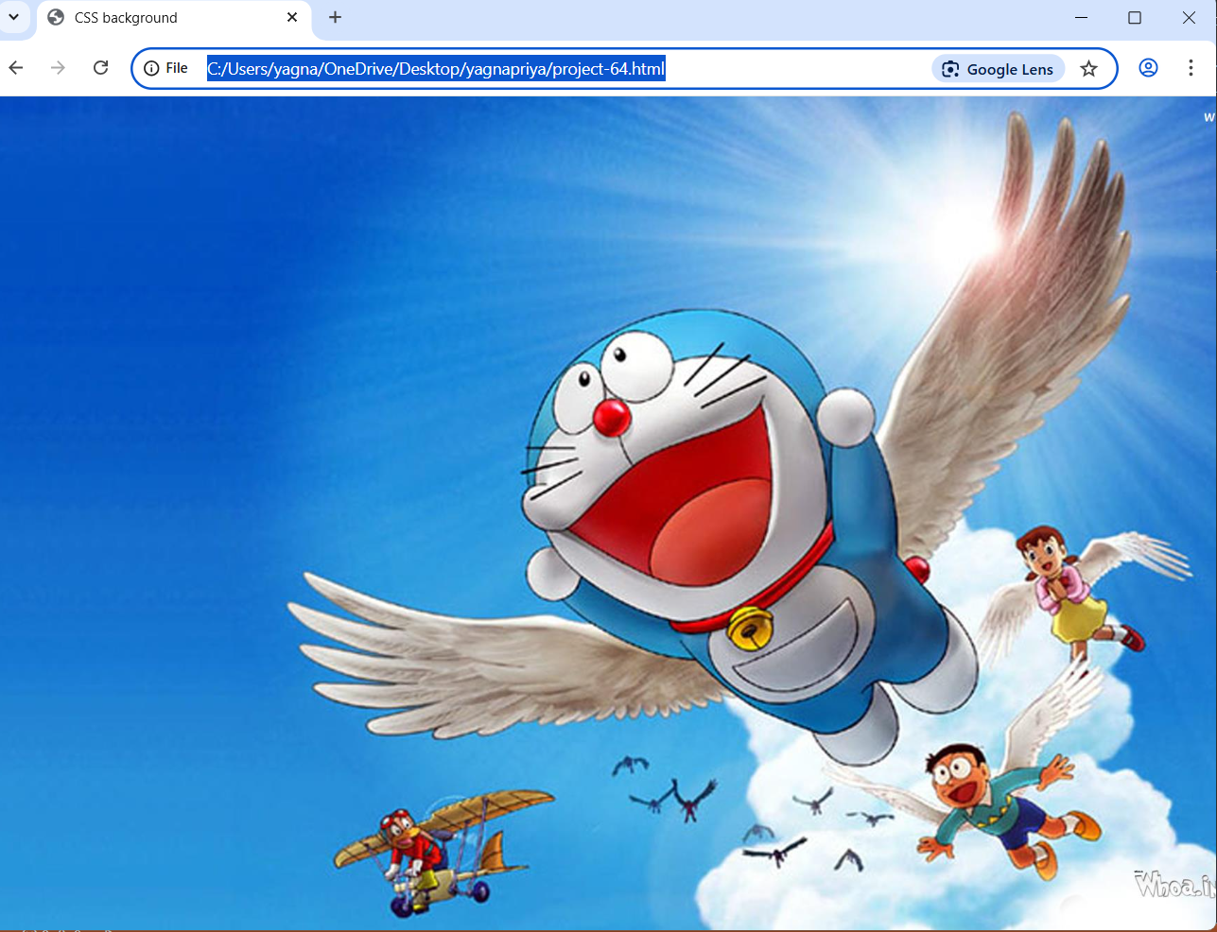

**Project-66**

**Title: Design a web page implementing the usage of CSS border property.**

**Source Code:**

<!DOCTYPE html>

<html>

    <head>

        <title>CSS Border</title>

        <link rel="stylesheet" href="CSS borders.css">

    </head>

    <body>

        <div>

            <h1>CSS BORDERS</h1>

            <p>In this page, you will learn how to set borders....!!!</p>

        </div>

    </body>

</html>

*CSS Code (CSS borders.css):*

div {

    border-style: dashed;

    border-color: indigo;

    border-width: 10px;

    padding: 10px;

}

**Output:**

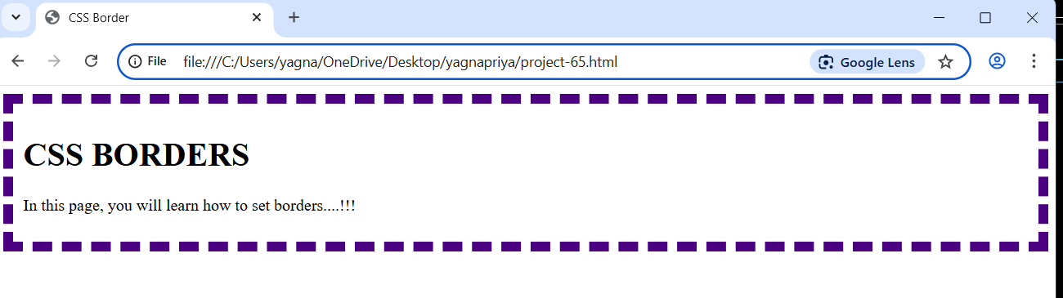

**Project-67**

**Title: Design a web page implementing the usage of CSS text property.**

**Source Code:**

<!DOCTYPE html>

<html>

    <head>

        <title>CSS text properties</title>

        <link rel="stylesheet" href="CSS text properties.css">

    </head>

    <body>

        <div>

            <h1>CSS text properties</h1>

            <p>You will learn CSS text properties </p>

        </div>

    </body>

</html>

*CSS Code (CSS text properties.css):*

h1 {

    color: coral;

    text-transform: uppercase;

    text-align: center;

}

p{

    text-align: center;

    letter-spacing: 10px;

    word-spacing: 20px;

    text-shadow: 10px 20px 2.5px black;

}

**Output:**

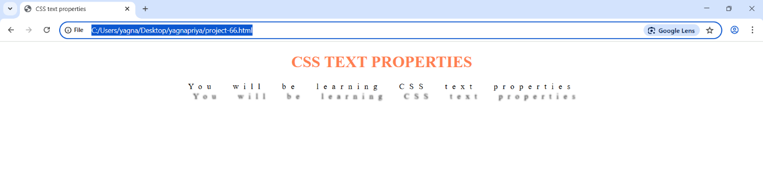

**Project-68**

**Title: Demonstrate the usage of Universal Selector(*) in CSS.**

**Source Code:**

<!DOCTYPE html>

<html>

    <head>

        <title>Universal Selecter</title>

        <style>

          * {

            margin: 0;

            padding: 0;

            color: brown;

          }

        </style>

    </head>

    <body>

        <h1>Helloooooooooo World</h1>

        <p>

            This text follows the universal reset.

        </p>

    </body>

</html>

**Output:**

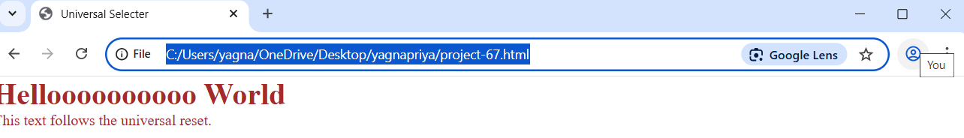

**Project-69**

**Title: Demonstrate the usage of the Type Selector(element) in CSS.**

**Source Code:**

<!DOCTYPE html>

<html>

    <head>

        <title>Type Selector</title>

        <style>

            p{

                color: blue;

                font-size: 18px;

            }

        </style>

    </head>

    <body>

        <p>This paragraph is blue.</p>

        <p>So is this one.</p>

    </body>

</html>

**Output:**

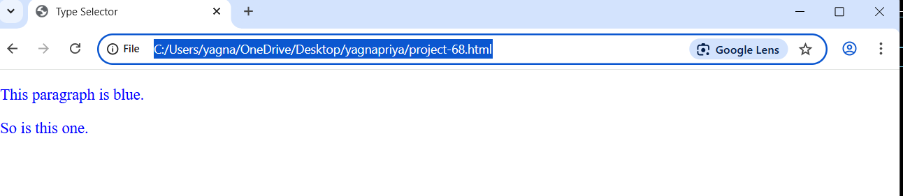

**Project-70**

**Title: Demonstrate the usage of the Class Selecctor(.classname) in CSS.**

**Source Code:**

<!DOCTYPE html>

<html>

    <head>

        <title>Class Selector</title>

        <style>

             .highlight {

                background-color: yellow;

             }

        </style>

    </head>

    <body>

        <p class="highlight"> This paragraph has a yellow background</p>

        <p>here we are listening css class</p>

    </body>

</html>

**Output:**

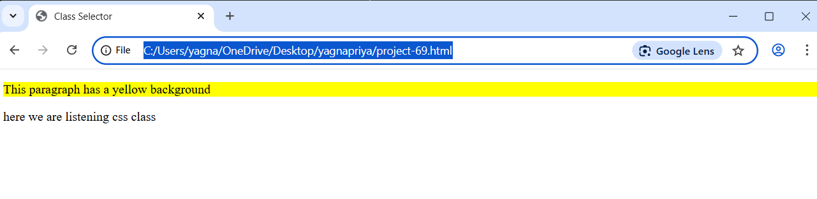

**Project-71**

**Title: Demonstrate the usage of the ID Selector(#id) in CSS.**

**Source Code:**

<!DOCTYPE html>

<html>

    <head>

        <title>ID selector</title>

        <style>

        #main-title {

                text-align: center;

                color: darkgreen;

        }

        </style>

    </head>

    <body>

        <h1 id="main-title">Welcome to My Site</h1>

        <h1>adhoc network tech company</h1>

    </body>

</html>

**Output:**

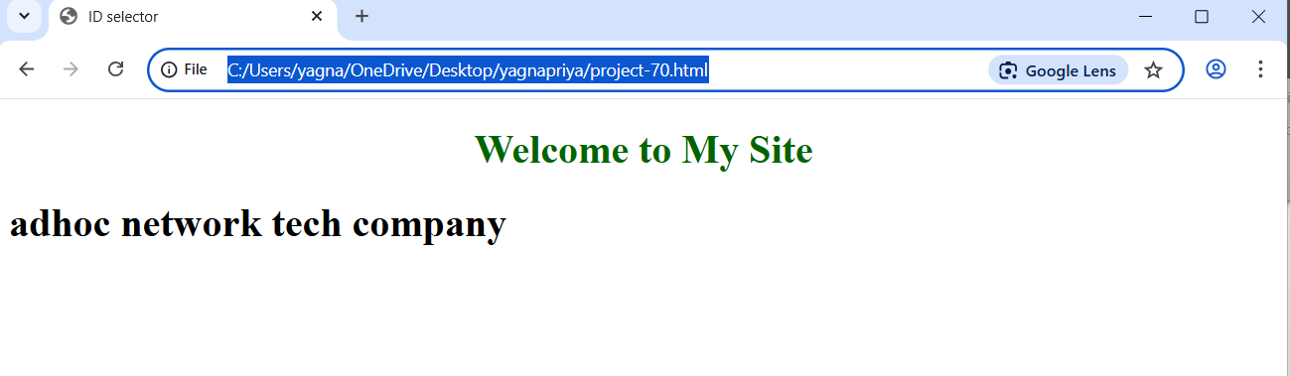

**Project-72**

**Title: Demonstrate the usage of the Descendant Combinator(A B) in CSS.**

**Source Code:**

<!DOCTYPE html>

<html>

    <head>

        <title>Descendant Combinator</title>

        <style>

            div p{

                color: red;

            }

    </style>

    </head>

    <body>

        <div>

            <p>This paragraph is red because it's inside a div.</p>

            <p>We are listening css class</p>

            <p>Descendant combinator</p>

        </div>

    </body>

</html>

**Output:**

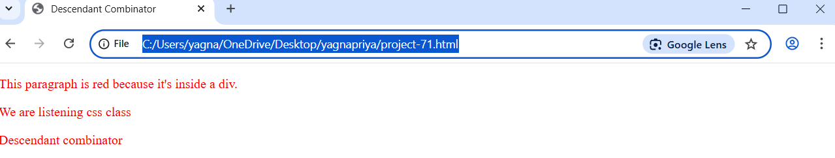

**Project-73**

**Title: Demonstrate the usage of Child Combinator (A > B) in CSS.**

**Source Code:**

<!DOCTYPE html>

<html>

    <head>

        <title>

            Child Combinator

        </title>

        <style>

            ul > li {

                color: red;

            }

        </style>

    </head>

    <body>

        <ul>

            <li>item 1</li>

            <ol>

                <li>sub 1</li>

                <li>sub 2</li>

            </ol>

            <li> Item 2</li>

        </ul>

    </body>

</html>

**Output:**

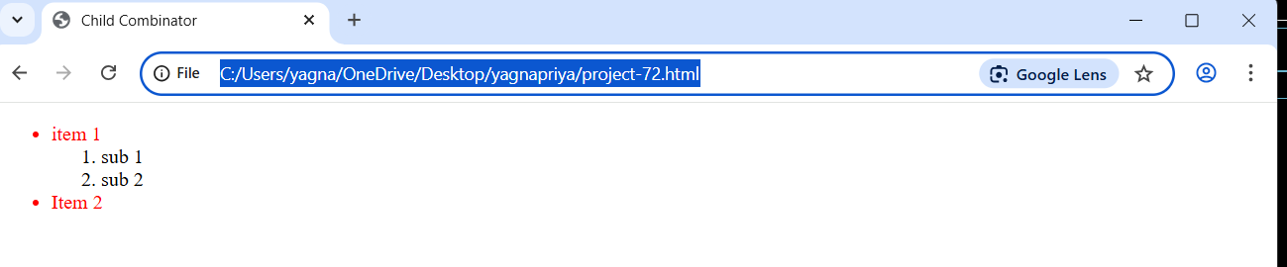

**Project-74**

**Title: Demonstrate the usage of Adjacent Sibling Combinator (A + B) in CSS.**

**Source Code:**

<!DOCTYPE html>

<html>

    <head><title>Adjacent Sibling Combinator</title>

    <style>

         h1 + p {

            color: orange;

         }

    </style></head>

        <body>

            <h1>Title</h1>

            <p>This paragraph is orange because it follows the h1.</p>

            <div>

                <h1>Title</h1>

            <p>This paragraph is orange because it follows the h1.</p>

            <h1>Title</h1>

            <p>This paragraph is orange because it follows the h1.</p>

            </div>

        </body>

</html>

**Output:**

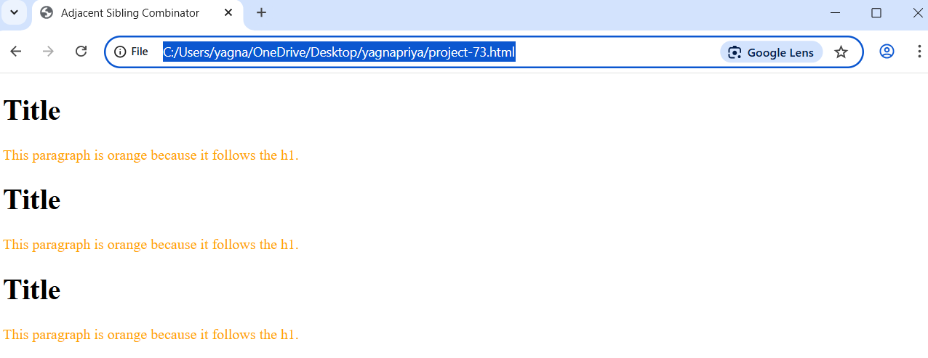

**Project-75**

**Title: Demonstrate the usage of General Sibling Combinator(A ~ B) in CSS.**

**Source Code:**

<!DOCTYPE html>

<html>

    <head>

        <title>General Sibling commbinator</title>

        <style>

           h2 ~ p {

            color: purple;

           }

        </style>

    </head>

    <body>

        <h2>Subheading</h2>

        <p>This is a purple paragraph.</p>

        <p>This is one too, since it's a sibling of h2.</p>

        <h1>Subheading</h1>

        <div>

            <p>This is a paragraph</p>

        </div>

    </body>

</html>

**Output:**

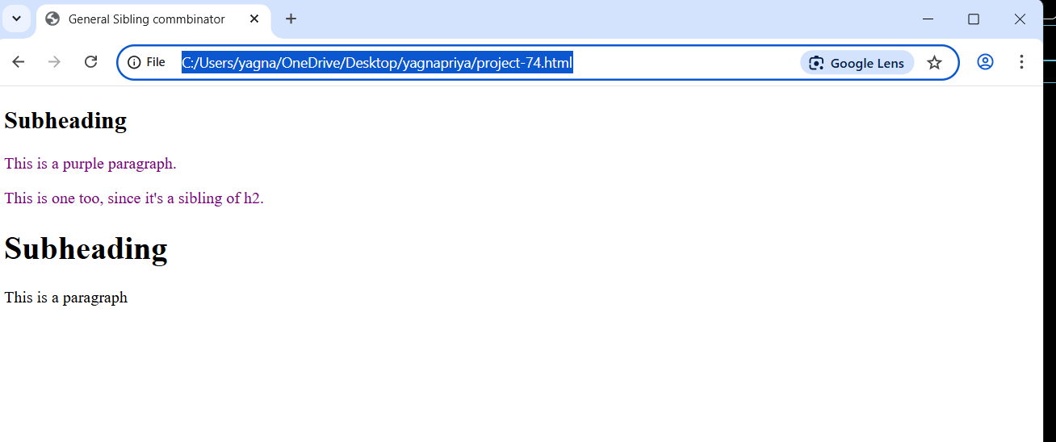

**Project-76**

**Title: Demonstrate the usage of ‘Border-radius’ for Rounded Corners in CSS.**

**Source Code:**

<!DOCTYPE html>

<html>

    <head>

        <title>Rounded Corners</title>

        <style>

            .rounded-box{

                width: 200px;

                height: 100px;

                background-color: lightcoral;

                border-radius: 20px;

                padding: 10px;

            }

        </style>

    </head>

    <body>

        <div class="rounded-box">This box has rounded Corners</div>

    </body>

</html>

**Output:**

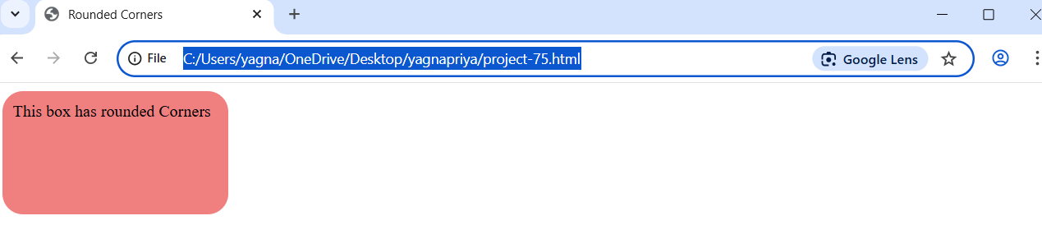

**Project-77**

**Title: Demonstrate the usage of ‘box-shadow’ in CSS.**

**Source Code:**

<!DOCTYPE html>

<html>

    <head>

        <title>Box Shadow</title>

        <style>

            .shadow-box {

                width: 200px;

                height: 100px;

                background-color: lightgreen;

                box-shadow: 10px 20px gray;

                padding: 10px;

            }

        </style>

    </head>

    <body>

        <div class="shadow-box">This box has a shadow</div>

    </body>

</html>

**Output:**

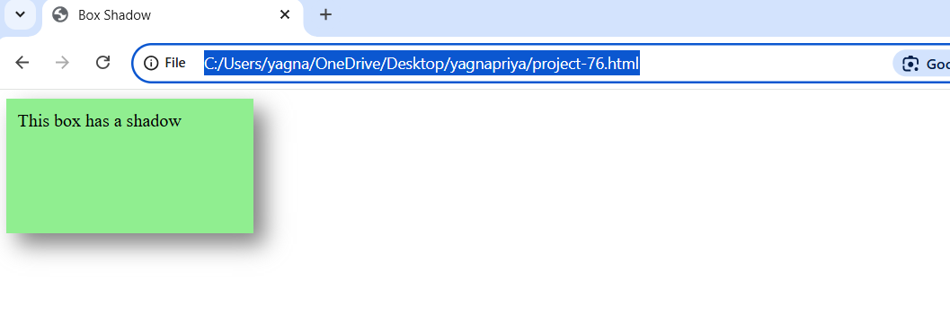

**Project-78**

**Title: Demonstrate the usage of ‘border-image in CSS.**

**Source Code:**

<!DOCTYPE html>

<html>

    <head>

        <title>Border Image</title>

        <style>

            .image-border{

                width: 250px;

               border: 20px solid transparent;

                border-image: url('image.jpg') 30 round;

                padding: 10px;

            }

        </style>

    </head>

    <body>

        <div class="image-border">This box uses an image as its border.</div>

    </body>

</html>

**Output:**

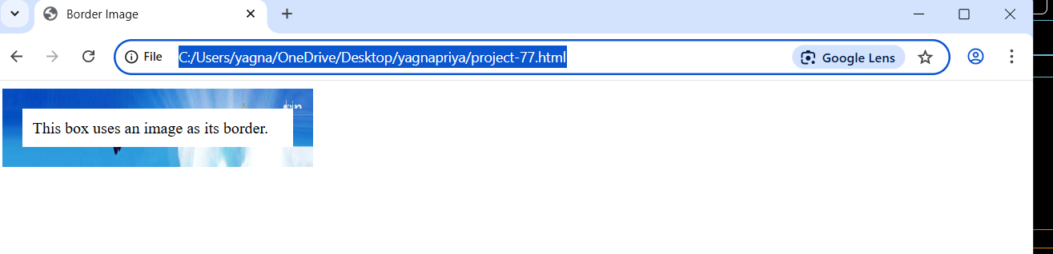

**Project-79**

**Title: Demonstrate how to style Table Borders using CSS.**

**Source Code:**

<!DOCTYPE html>

<html>

    <head>

        <title>Table Border</title>

        <style>

            table{

                border: 2px solid black;

                border-collapse: collapse;

                width: 50%;

            }

            th, td {

                border: 1px solid gray;

                padding:8px;

                text-align: center

}

        </style>

    </head>

    <body>

        <table>

            <tr>

                <th>Name</th><th>Age</th>

            </tr>

            <tr><td>Sasi</td><td>19</td></tr>

            <tr><td>Ramesh</td><td>18</td></tr>

        </table>

    </body>

</html>

**Output:**

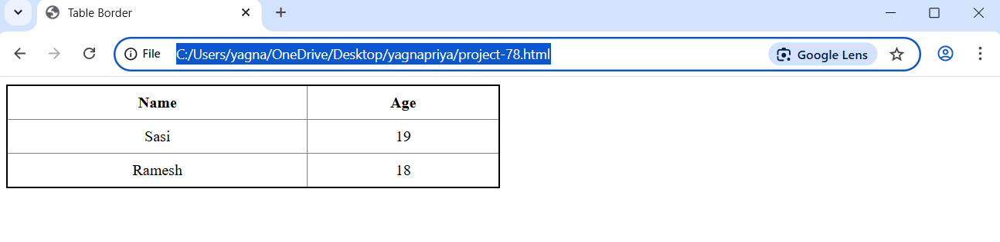

**Project-80**

**Title: Demonstrate the usage of the ‘display-block’ in CSS.**

**Source Code:**

<!DOCTYPE html>

<html>

    <head>

        <title>Display box</title>

        <style>

          .block-example{

            display: block;

            background-color: pink;

            padding: 10px;

            margin-bottom: 10px;

          }

        </style>

    </head>

    <body>

        <img src="Image.jpg" alt="Doremon" width="200px" height="200px" class="block-example">

        <span>This is another span.</span>

    </body>

</html>

**Output:**

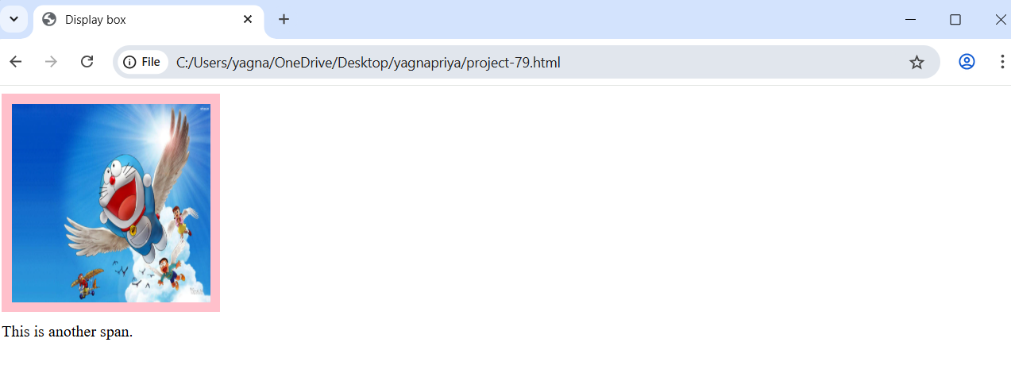

**Project-81**

**Title: Demonstrate the usage of the ‘display: inline’ property inn CSS.**

**Source Code:**

<!DOCTYPE html>

<html>

    <head>

        <title>Dispaly inline</title>

        <style>

           .inline-example {

            display: inline;

            background-color: lightgreen;

            padding: 5px;

           }

        </style>

    </head>

    <body>

        <div class="inline-example">This div behaves inline.</div>

        <div class="inline-example">Another inline div.</div>

    </body>

</html>

**Output:**

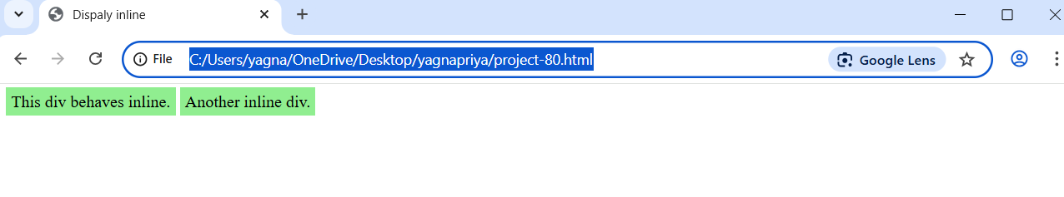

**Project-82**

**Title: Demonstrate the usage of the ‘display: inline-block’ property in CSS.**

**Source Code:**

<!DOCTYPE html>

<html>

    <head>

        <title>Display inline-Block</title>

        <style>

           .inline-block-example {

            display: inline-block;

            width: 150px;

            height: 100px;

            background-color: lightcoral;

            margin: 5px;

            text-align: center;

            line-height: 100px;

           }

        </style>

    </head>

    <body>

        <div class="inline-block-example">Box 1</div>

        <div class="inline-block-example">Box 2</div>

    </body>

</html>

**Output:**

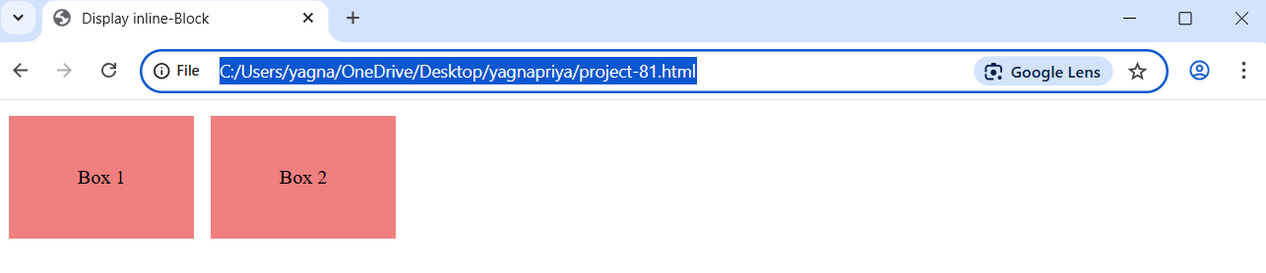

**Project-83**

**Title: Demonstrate the usage of the ‘display: none’ property in CSS.**

**Source Code:**

<!DOCTYPE html>

<html>

    <head>

        <title>Dispaly None</title>

        <style>

            .hidden {

                display: none;

            }

        </style>

    </head>

    <body>

        <p>This paragraph is visible.</p>

        <p class="hidden">This paragraph is hidden.</p>

    </body>

</html>

**Output:**

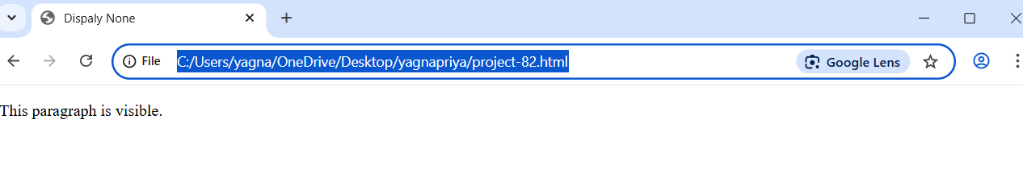

**Project-84**

**Title: Demonstrate the usage of the ‘display: flex’ in CSS.**

**Source Code:**

<!DOCTYPE html>

<html>

    <head>

        <title>Flex Example</title>

        <style>

            .flex-container {

                display: flex;

                background-color: lightgray;

                padding: 10px;

            }

            .flex-container div {

                background-color: skyblue;

                margin: 10px;

                padding: 20px;

                font-size: 18px;

            }

        </style>

    </head>

    <body>

        <div class="flex-container">

            <div>BOx 1 </div>

          <div>BOx 2 </div>

               <div>BOx 3 </div>

        </div>

    </body>

</html>

**Output:**

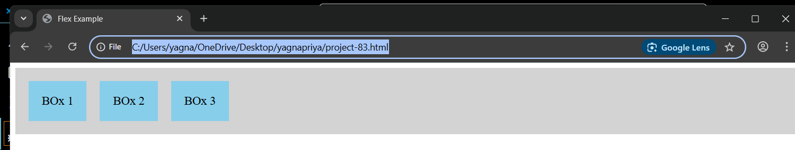

**Project-85**

**Title: Demonstrate the usage of the ‘flex-direction’ in CSS.**

**Source Code:**

<!DOCTYPE html>

<html>

    <head>

        <title>Flex Direction</title>

        <style>

            .flex-container {

                display: flex;

                flex-direction: column;

                background-color: lightgray;

                padding: 10px;

            }

            .flex-container div {

                background-color: lightcoral;

                margin: 10px;

                padding: 15px;

            }

        </style>

    </head>

    <body>

       <div class="flex-container" >

        <div>Item 1</div>

        <div>Item 2</div>

        <div>Item 3</div>

       </div>

    </body>

</html>

**Output:**

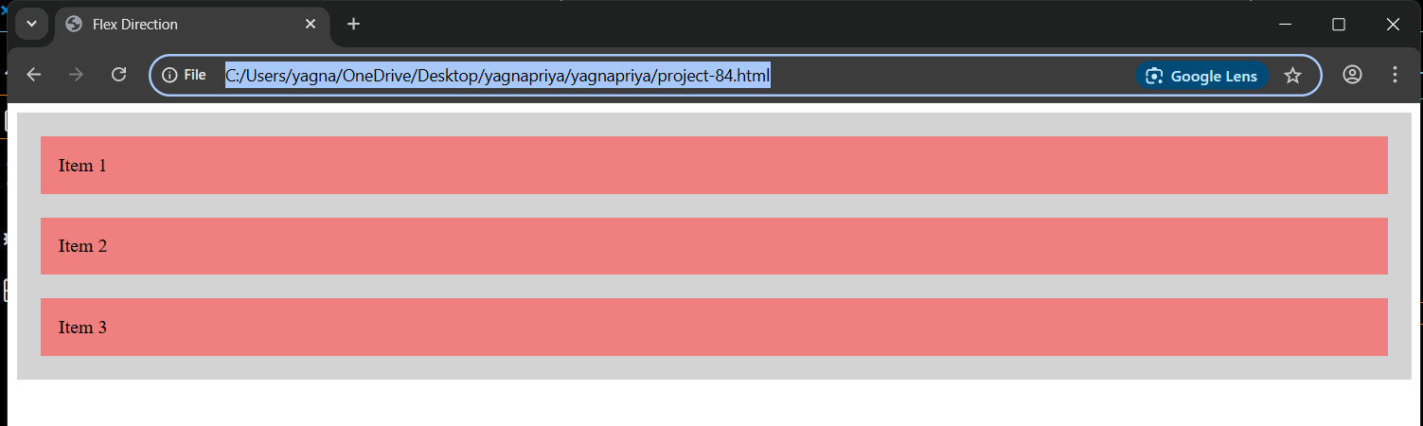

**Project-86**

**Title: Demonstrate the usage of the ‘flex-wrap’ property in CSS.**

**Source Code:**

<!DOCTYPE html>

<html>

    <head>

        <title>Flex Wrap</title>

        <style>

          .flex-container {

            display: flex;

            flex-wrap: wrap;

            background-color: lightgray;

          }

          .flex-container div{

            background-color: green;

            width: 150px;

            margin: 10px;

            padding: 10px;

            font-size: 18px;

          }

        </style>

    </head>

    <body>

        <div class="flex-container">

            <div>Item A</div>

            <div>Item B</div>

             <div>Item C</div>

             <div>Item D</div>

        </div>

    </body>

</html>

**Output:**

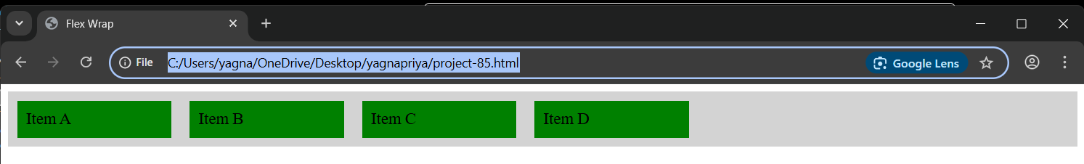

**Project-87**

**Title: Demonstrate the usage of the ‘flex-flow’ in CSS.**

**Source Code:**

<!DOCTYPE html>

<html>

    <head>

        <title>

            Flex Flow

        </title>

        <style>

            .flex-container {

                display: flex;

                flex-flow: row wrap;

                background-color: lightgray;

            }

            .flex-container div{

                background: orange;

                width: 160px;

                margin: 10px;

                padding: 10px;

                font-size: 16px;

            }

        </style>

    </head>

    <body>

        <div class="flex-container">

            <div>Block 1</div>

            <div>Block 2</div>

            <div>Block 3</div>

        </div>

    </body>

</html>

**Output:**

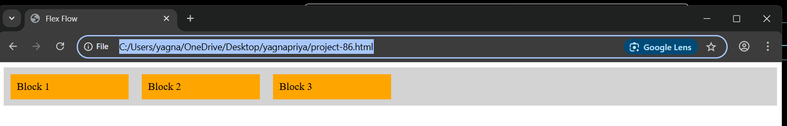

**Project-88**

**Title: Demonstrate the usage of the ‘justify-content’ in CSS.**

**Source Code:**

<!DOCTYPE html>

<html>

    <head>

        <title>Justify Contant</title>

        <style>

         .flex-container {

            display: flex;

            justify-content: space-between;

            background-color: lightgray;

            padding: 10px;

         }

         .flex-container div {

            background-color: skyblue;

            padding: 20px;

            font-size: 16px;

         }

        </style>

    </head>

    <body>

        <div class="flex-container">

            <div>Left</div>

            <div>Middle</div>

            <div>Right</div>

        </div>

    </body>

</html>

**Output:**

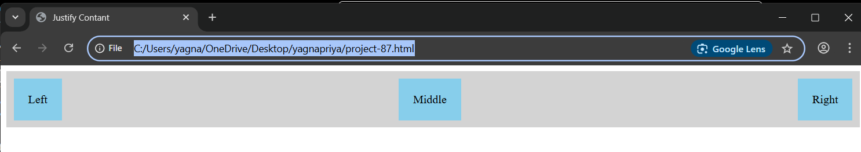

**Project-89**

**Title: Demonstrate the usage of the ‘align-items’ in CSS.**

**Source Code:**

<!DOCTYPE html>

<html>

    <head>

        <title>Align Items</title>

        <style>

        .flex-container {

            display: flex;

            align-items: center;

            height: 150px;

            background-color: lightgray;

        }

        .flex-container div {

            background-color: plum;

            padding: 20px;

            font-size: 18px;

        }

        </style>

    </head>

    <body>

         <div class="flex-container">

            <div>Vertically</div>

            <div>Centered</div>

         </div>

    </body>

</html>

**Output:**

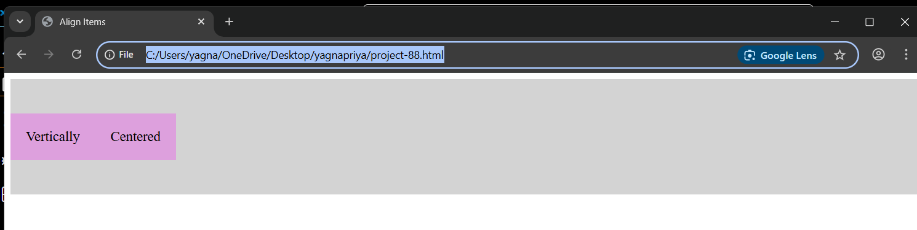

**Project-90**

**Title: Demonstrate the usage of the ‘align-content’ in CSS.**

**Source Code:**

<!DOCTYPE html>

<html>

    <head>

        <title>Align Contant</title>

        <style>

         .flex-container {

            display: flex;

            flex-wrap: wrap;

            align-content: center;

            height: 300px;

            background-color: lightgray;

         }

         .flex-container div {

            background-color: lightpink;

            width: 120px;

            height: 80px;

            margin: 10px;

            text-align: center;

            line-height: 80px;

         }

        </style>

    </head>

    <body>

        <div class="flex-container">

        <div>One</div>

        <div>Two</div>

        <div>Three</div>

        <div>Four</div>

        </div>

    </body>

</html>

**Output:**

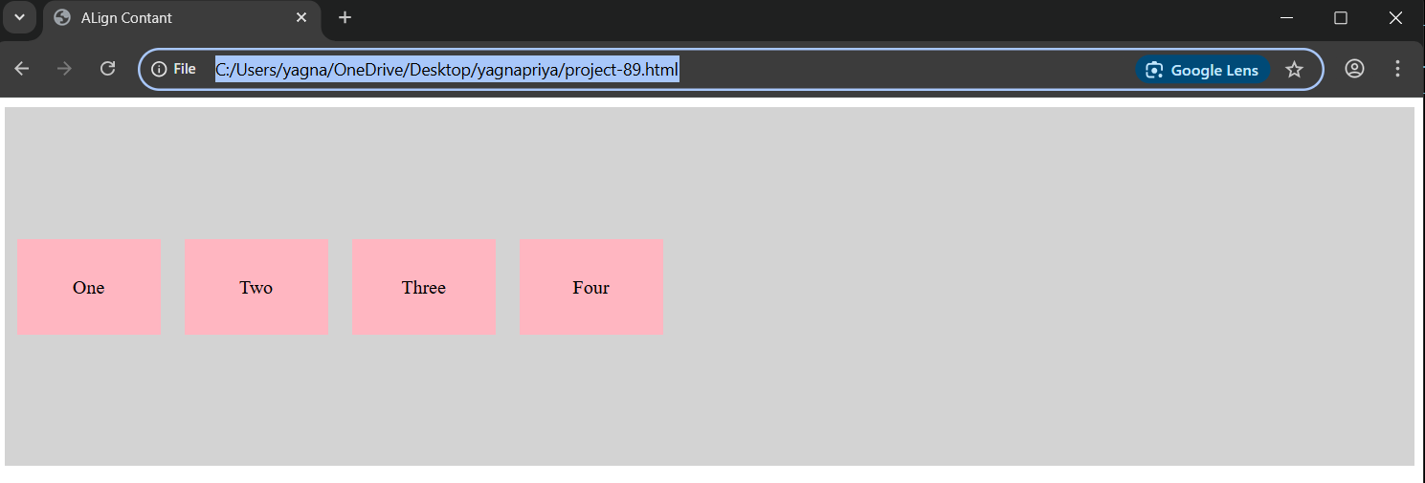**Project-91**

**Title: Demonstrate the usage of the ‘a:link’ in CSS.**

**Source Code:**

<!DOCTYPE html>

<html>

    <head>

        <title>Link - a.link</title>

        <style>

          a:link {

            color: blue;

            text-decoration: none;

            font-weight: bold;

          }

        </style>

    </head>

    <body>

      <a href="https://www.youtube.com/">Visit Example</a>

    </body>

</html>

**Output:**

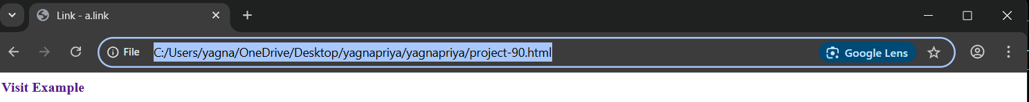

**Project-92**

**Title: Demonstrate the usage of the ‘a: visited’ in CSS.**

**Source Code:**

<!DOCTYPE html>

<html>

    <head>

        <title>Visited Link</title>

        <style>

         .a:visited {

            color: purple;

         }

        </style>

    </head>

    <body>

        <a href="https://www.youtube.com/">Visit Example</a>

    </body>

</html>

**Output:**

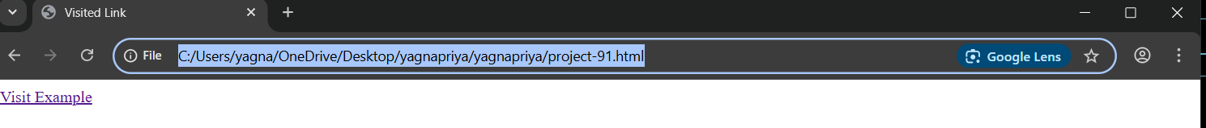

**Project-93**

**Title: Demonstrate the usage of the ‘display: none’ property in CSS.**

**Source Code:**

<!DOCTYPE html>

<html>

    <head>

        <title>Hover</title>

        <style>

           a:hover {

            color: red;

            text-decoration: underline;

           }

        </style>

    </head>

    <body>

        <a href="https://www.youtube.com/">Hover over me</a>

    </body>

</html>

**Output:**

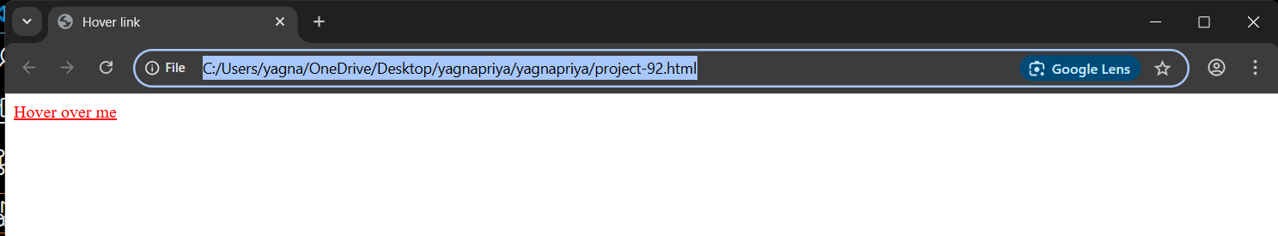

**Project-94**

**Title: Demonstrate the usage of the ‘a: active’ in CSS.**

**Source Code:**

<!DOCTYPE html>

<html>

    <head>

        <title>Active link</title>

        <style>

          a:active {

            color: orange;

          }

        </style>

    </head>

    <body>

        <a href="https://www.youtube.com/">Click Me</a>

    </body>

</html>

**Output:**



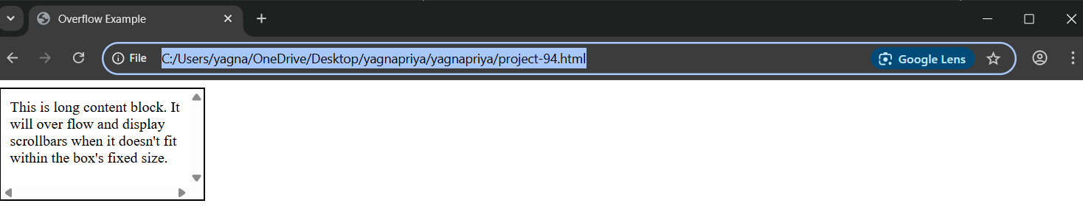

**Project-96**

**Title: Demonstrate the usage of the ‘float’ property in CSS.**

**Source Code:**

<!DOCTYPE html>

<html>

    <head>

        <title>Float Example</title>

        <style>

          img {

            float: left;

            margin-right: 15px;

          }

        </style>

    </head>

    <body>

       <img src="india.jpg" alt="sample">

       <p>This text wraps around the images that is floated to the left.</p>

    </body>

</html>

**Output:**

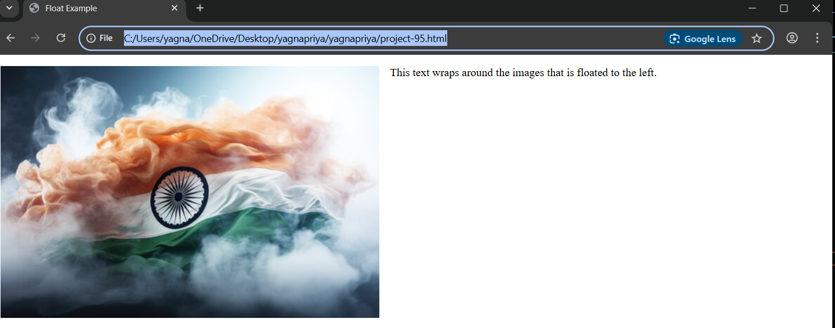

**Project-97**

**Title: Demonstrate the usage of the ‘calc()’ in CSS.**

**Source Code:**

<!DOCTYPE html>

<html>

    <head>

        <title>CSS Cals</title>

        <style>

              .calc-box {

                 width: calc(100%-500px);

                 background-color: lightblue;

                 padding: 20px;

              }

        </style>

    </head>

    <body>

        <div class="calc-box"> This box is 50px less than the full width of the page.</div>

    </body>

</html>

**Output:**

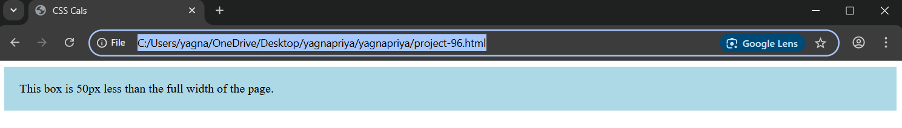

**Project-98**

**Title: Demonstrate the usage of the ‘min()’ in CSS.**

**Source Code:**

<!DOCTYPE html>

<html>

    <head>

        <title>CSS Min Function</title>

        <style>

             .min-box {

                width: min(80%-300px);

                 background-color: lightcoral;

                 padding: 20px;

             }

        </style>

    </head>

    <body>

        <div class="min-box">This box is no wider than 300px or 80% of the screen, whichever is smaller.</div>

    </body>

</html>

**Output:**

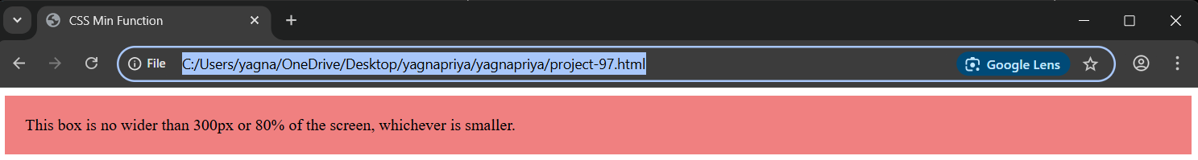

**Project-99**

**Title: Demonstrate the usage of the ‘max()’ in CSS.**

**Source Code:**

<!DOCTYPE html>

<html>

    <head>

        <title>CSS Max Function</title>

        <style>

          .max-box  {

            width: min(200px-50%);

                 background-color: lightgreen;

                 padding: 20px;

          }

        </style>

    </head>

    <body>

        <div class="max-box">This box will be at least 200px or 50% of the screen,whichever is larger.</div>

    </body>

</html>

**Output:**

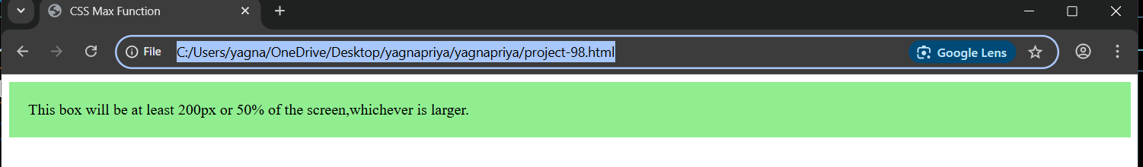

**Project-100**

**Title: Demonstrate the usage of the ‘::first-line’ in CSS.**

**Source Code:**

<!DOCTYPE html>

<html>

    <head>

        <title>First Line</title>

        <style>

          p::first-line {

            font-weight: bold;

            color: red;

          }

        </style>

    </head>

    <body>

        <p>This is a long paragraph demonstrating how the first line gets a different style using

        the ::first-line pseudo-element. The rest of the paragraph looks normal. I'm practice VScode.</p>

    </body>

</html>

**Output:**

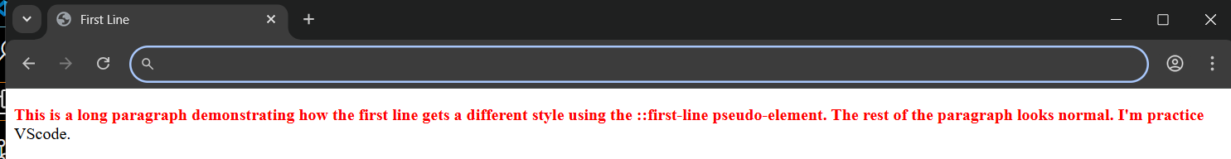

**Project-101**

**Title: Demonstrate the usage of the ‘::first-letter’ in CSS.**

**Source Code:**

<!DOCTYPE html>

<html>

    <head>

        <title>First Letter</title>

        <style>

           p::first-letter {

                font-size: 200%;

                color: blue;

           }

             </style>

    </head>

    <body>

        <p>This is a long paragraph demonstrating how the first line gets a different style using the ::first-letter pseudo-element. The rest of the paragraph looks normal.</p>

    </body>

</html>

**Output:**

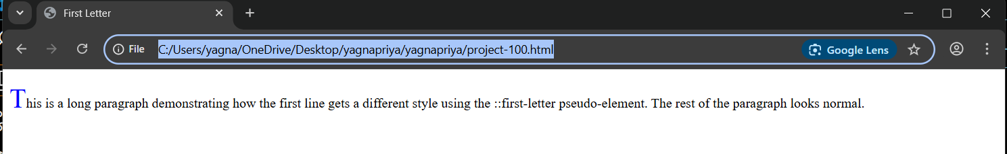

**Project-102**

**Title: Demonstrate the usage of the ‘::before’ in CSS.**

**Source Code:**

<!DOCTYPE html>

<html>

    <head>

        <title>Before element</title>

        <style>

           h1::before{

            content: "⭐";

            color: gold;

           }

        </style>

    </head>

    <body>

        <h1>Welcome</h1>

    </body>

</html>

**Output:**

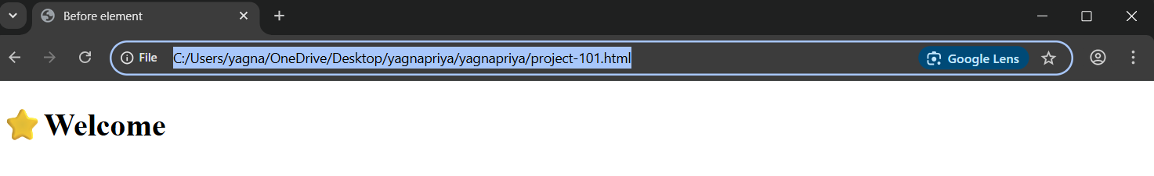

**Project-103**

**Title: Demonstrate the usage of the ‘::after’ property in CSS.**

**Source Code:**

<!DOCTYPE html>

<html>

    <head>

        <title>After element</title>

        <style>

        h1::after {

            content:"✅" ;

            color: green;

        }

        </style>

    </head>

    <body>

        <h1>Task Complete</h1>

    </body>

</html>

**Output:**

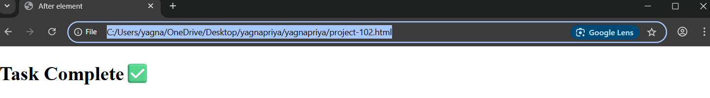

**Project-104**

**Title: Demonstrate the usage of the ‘::selection’ in CSS.**

**Source Code:**

<!DOCTYPE html>

<html>

    <head>

        <title>Selection</title>

        <style>

            p::selection {

                background: yellow;

                color:black ;

            }

        </style>

    </head>

    <body>

        <p>Try selecting this text to see the custom selection styling.</p>

    </body>

</html>

**Output:**

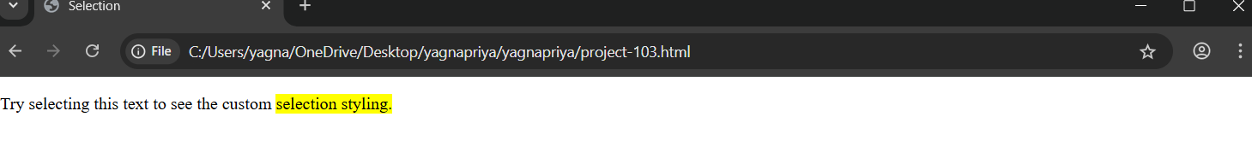

**Project-105**

**Title: Demonstrate the usage of the ‘:nth-child()’ in CSS.**

**Source Code:**

<!DOCTYPE html>

<html>

    <head>

        <title>nth-child</title>

        <style>

            li:nth-child(Odd) {

            background-color: lightblue;

            }

        </style>

    </head>

    <body>

        <ul>

            <li>Item 1</li>

            <li>Item 2</li>

            <li>Item 3</li>

            <li>Item 4</li>

        </ul>

    </body>

</html><!DOCTYPE html>

<html>

    <head>

        <title>nth-child</title>

        <style>

            li:nth-child(Odd) {

            background-color: lightblue;

            }

        </style>

    </head>

    <body>

        <ul>

            <li>Item 1</li>

            <li>Item 2</li>

            <li>Item 3</li>

            <li>Item 4</li>

        </ul>

    </body>

</html>

**Output:**

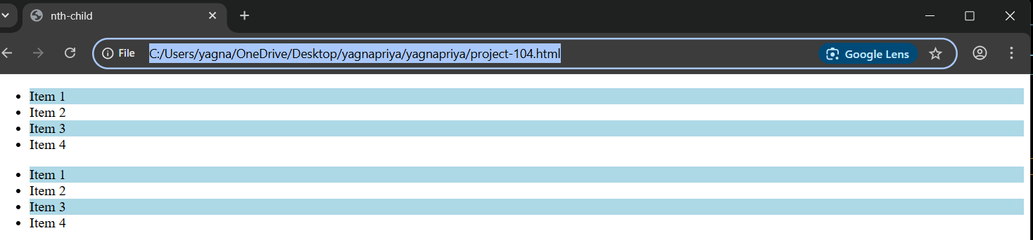

**Project-106**

**Title: Demonstrate the usage of the ‘:target’ in CSS.**

**Source Code:**

<!DOCTYPE html>

<html>

    <head>

      <title>Target Example</title>

    <style>

      div:target {

        background-color: yellow;

        border: 2px solid black;

      }

    </style>

    </head>

    <body>

      <a href="#section">Go to Section 1</a>

      <div id="section" style="margin-top: 50px; padding: 10px;">This is section 1</div>

    </body>

    </html>

**Output:**

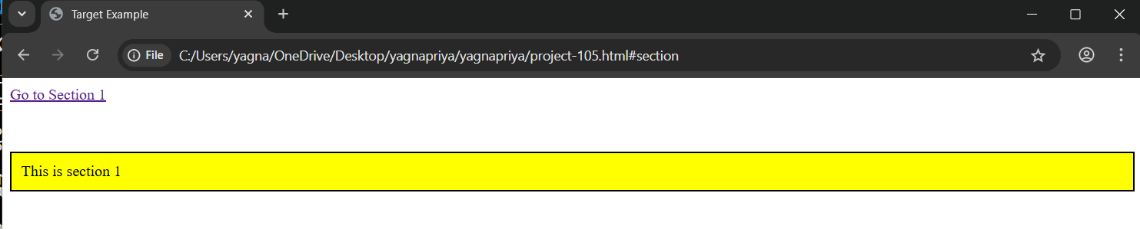

**Project-107**

**Title: Demonstrate the usage of the ‘input[type=”text”]’ in CSS.**

**Source Code:**

<!DOCTYPE html>

<html>

    <head>

        <title>

            Attribute Selection

        </title>

        <style>

            input[text="text"] {

                border: 2px solid green;

                padding: 5px;

            }

        </style>

    </head>

    <body>

        <input type="text" placeholder="Enter name">

         <input type="password" placeholder="Password">

    </body>

</html>

**Output:**

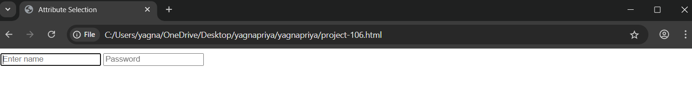

**Project-108**

**Title: Demonstrate the usage of the ‘::placeholder’ in CSS.**

**Source Code:**

<!DOCTYPE html>

<html>

    <head>

        <title>

            placeholder Styling

        </title>

        <style>

            input::placeholder {

                color: gray;

                font-style: italic;

            }

        </style>

    </head>

    <body>

        <input type="text" placeholder="Type your name here">

    </body>

</html>

**Output:**

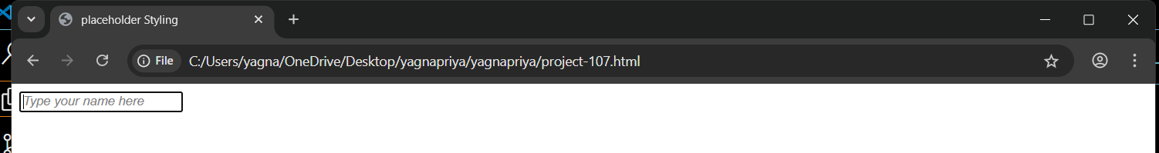

**Project-109**

**Title: Demonstrate the usage of the ‘z-index’ in CSS.**

**Source Code:**

<!DOCTYPE html>

<html>

    <head>

        <title>

            Z-index Example

        </title>

    <style>

        .box1 {

            position: absolute;

            top: 50px;

            left: 50px;

            width: 150px;

            height: 150px;

            background-color: red;

            z-index: 1;

        }

        .box2 {

            position: absolute;

            top: 100px;

            left: 100px;

            width: 150px;

            height: 150px;

            background-color: blue;

            z-index: 2;

        }

    </style>

    </head>

    <body>

        <div class="box1"></div>

        <div class="box2"></div>

    </body>

</html>

**Output:**

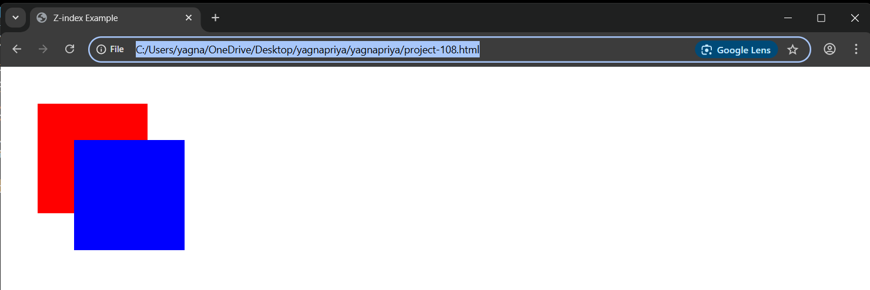

**Project-110**

**Title: Demonstrate the usage of ‘input[type=”range”] in CSS.**

**Source Code:**

<!DOCTYPE html>

<html>

    <head>

        <title>Range input</title>

        <style>

        input[type="range"] {

        width: 300px;

        accent-color: teal;

        }

        </style>

    </head>

    <body>

      <label for="volume">Volume:</label>

      <input type="range" id="volume" name="volume" min="0" max="100">

    </body>

</html>

**Output:**

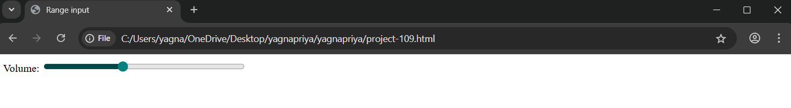

**Project-111**

**Title: Demonstrate the usage of ‘<progress>’ element in CSS.**

**Source Code:**

<!DOCTYPE html>

<html>

    <head>

        <title>progress Example</title>

        <style>

             progress {

                width: 300px;

                height: 20px;

                accent-color: green;

             }

        </style>

    </head>

    <body>

         <label>Download Progress</label>

         <progress value="60" max="100"></progress>

    </body>

</html>

**Output:**

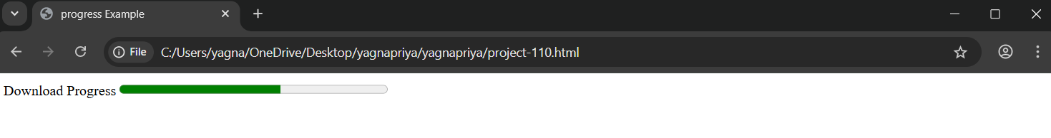

**Project-112**

**Title: Demonstrate the usage of ‘accent-color’ in CSS.**

**Source Code:**

<!DOCTYPE html>

<html>

    <head>

        <title>Accent Color</title>

        <style>

             input[type="chackbox"] {

                accent-color: purple;

             }

        </style>

    </head>

    <body>

         <label><input type="checkbox" checked>Accept Terms</label>

    </body>

</html>

**Output:**

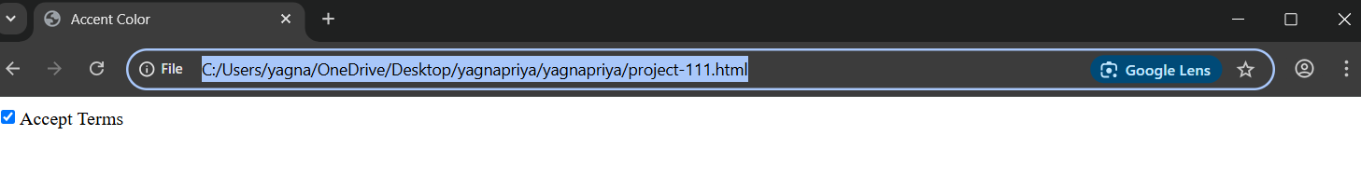

**Project-113**

**Title: Demonstrate a simple CSS animation using “@keyframes”.**

**Source Code:**

<!DOCTYPE html>

<html>

    <head>

        <title>CSS Animation</title>

        <style>

            .animated-box {

                width: 100px;

                height: 100px;

                background-color: coral;

                animation-name: changeColor;

                animation-duration: 2s;

                animation-iteration-count: infinite;

                animation-direction: alternate;

            }

            @keyframes changeColor {

                from { background-color: coral;}

                to {background-color: dodgerblue;}

            }

        </style>

    </head>

    <body>

         <div class="animated-box"></div>

    </body>

</html>

**Output:**

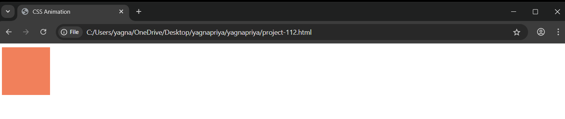

**Project-114**

**Title: Demonstrate the usage of backdrop-filter in CSS.**

**Source Code:**

<!DOCTYPE html>

<html>

    <head>

        <title>Backdrop Filter</title>

        <style>

            body {

                background: url('india.jpg') no-repeat center/cover;

                height: 100vh;

                margin: 0;

            }

            .glass {

                width: 600px;

                height: 400px;

                margin: 50px auto;

                background-color: rgba(255, 255, 255, 0.3);

                backdrop-filter: blur(5px);

                border-radius: 10px;

                padding: 20px;

                color: black;

            }

        </style>

    </head>

    <body>

         <div class="glass">

            <h2>Glass Effect</h2>

            <p>This box uses backdrop-filter: blur for a frosted-glass effect.</p>

         </div>

    </body>

</html>

**Output:**

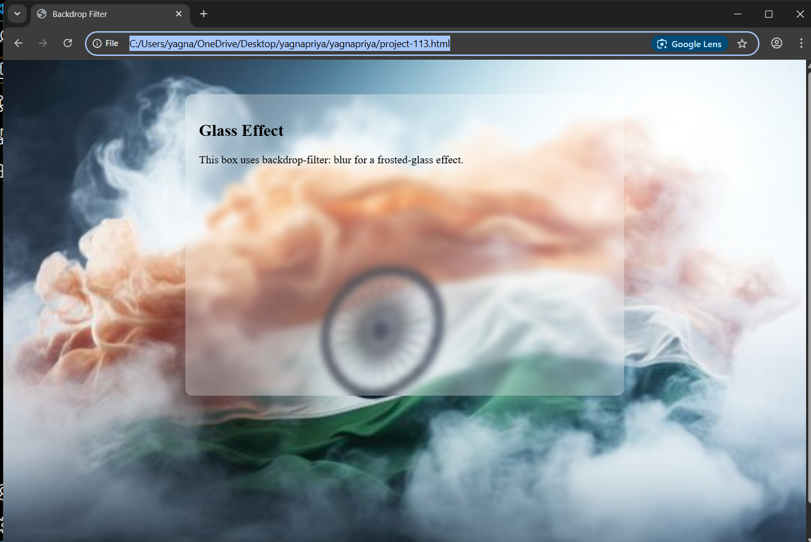

**Project-115**

**Title: Demonstrate the usage of ‘transform: translate()’ in CSS.**

**Source Code:**

<!DOCTYPE html>

<html>

    <head>

        <title>Translate Transform</title>

        <style>

            .box {

                width: 100px;

                height: 100px;

                background-color: orange;

                transform: translate(50px, 30px);

            }

        </style>

    </head>

    <body>

         <div class="box"></div>

    </body>

</html>

**Output:**

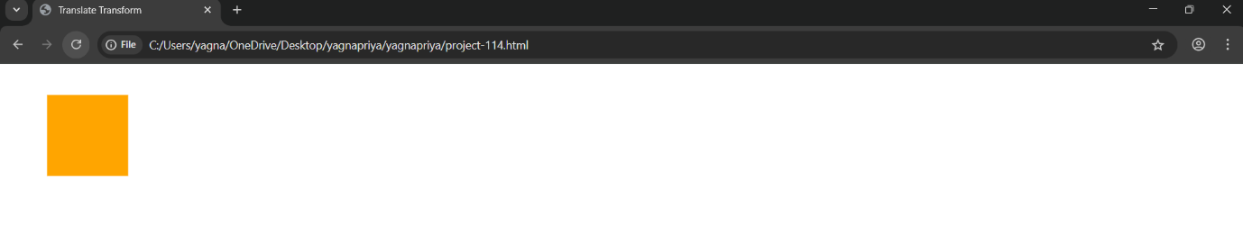

**Project-116**

**Title: Demonstrate the usage of ‘transform: rotate()’ in CSS.**

**Source Code:**

<!DOCTYPE html>

<html>

    <head>

        <title>Rotate Transform</title>

        <style>

         .box {

            width: 100px;

            height: 100px;

            background-color: red;

            transform: rotate(45deg);

         }

        </style>

    </head>

    <body>

        <div class="box"></div>

    </body>

</html>

**Output:**

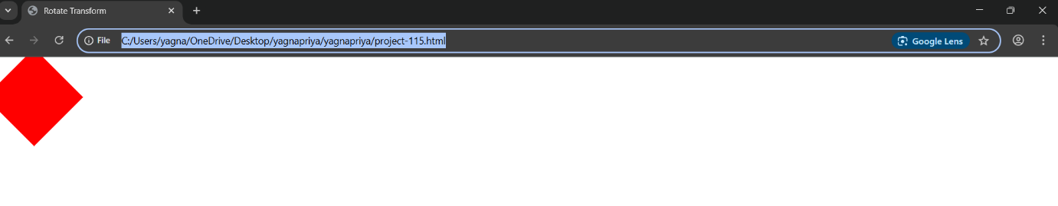

**Project-117**

**Title: Demonstrate the usage of ‘transform: scale() in CSS.**

**Source Code:**

<!DOCTYPE html>

<html>

    <head>

        <title>scale Transform</title>

        <style>

           .box {

            width: 200px;

            height: 200px;

            background-color: lightseagreen;

            transform:scale(1.5,1.2)

           }

        </style>

    </head>

    <body>

        <div class="box"></div>

    </body>

</html>

**Output:**

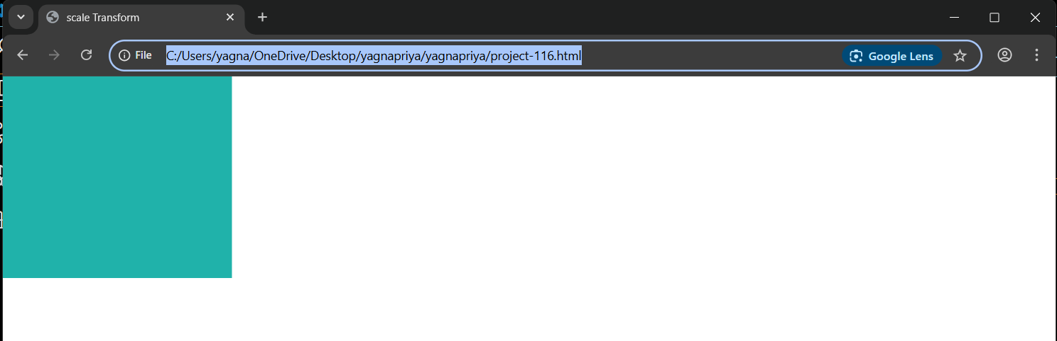

**Project-118**

**Title: Demonstrate the usage of ‘counter-increment’ in CSS.**

**Source Code:**

<!DOCTYPE html>

<html>

    <head>

        <title>Counter Increment</title>

        <style>

         body {

            counter-reset: section;

         }

         h2::before {

            counter-increment: section;

            content: "Section" counter(section) ":";

            font-weight: bold;

         }

        </style>

    </head>

    <body>

        <h2>Introduction</h2>

        <h2>Features</h2>

        <h2>Conclusion</h2>

    </body>

</html>

**Output:**

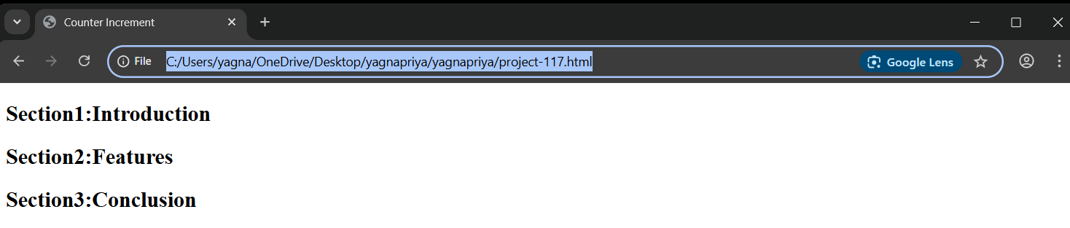

**JavaScript**

**Project-119**

**Title: Demonstrate the usage of ‘getElementById’ to access and modify an element.**

**Source Code:**

<!DOCTYPE html>

<html>

    <head>

        <title>getElementById Example</title>

    </head>

    <body>

        <h1 id="title">Original Title</h1>

        <script>

            document.getElementById("title").textContent = "Modified by JavaScript";

        </script>

    </body>

</html>

**Output:**

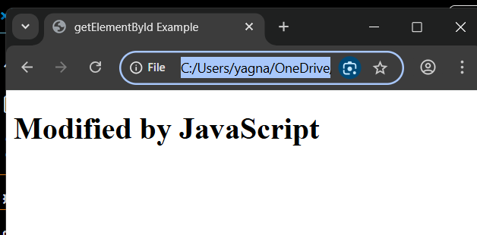

**Project-120**

**Title: Demonstrate the usage of ‘getElementsByClassName’ to access multiple elements.**

**Source Code:**

<!DOCTYPE html>

<html>

    <head>

        <title>getElementByClassName Example</title>

    </head>

    <body>

          <p class="item">Item 1</p>

          <p class="item">Item 2</p>

          <button onclick="'updateItems()">Update First Items</button>

          <script>

            function updateItems() {

                const items = documenting.getElementsByClassName("item");

                items[0].textContent = "First Item Updated!";

            }

          </script>

    </body>

</html>

**Output:**

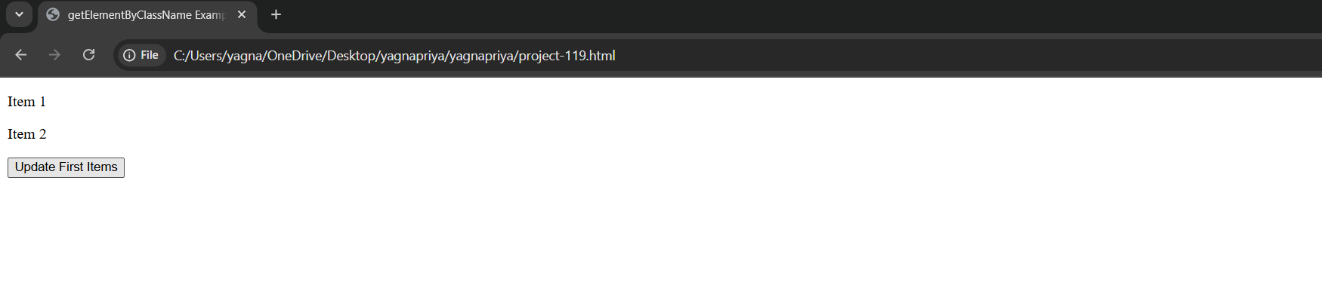

**Project-121**

**Title: Demonstrate how to change content using ‘textcontent’ with a button click.**

**Source Code:**

<!DOCTYPE html>

<html>

    <head>

        <title>textContent Example</title>

    </head>

    <body>

        <div id="info"><b>Hello</b> World </div>

        <button onclick="changeText()">Change Text</button>

        <script>

            function changeText() {

                document.getElementById("info").textContent = "Plain text only!";

            }

        </script>

    </body>

</html>

**Output:**

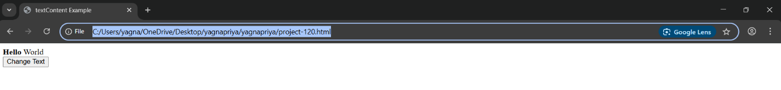

**Project-122**

**Title: Demonstrate hoe to change content using ‘innerHTML’ with abutton click.**

**Source Code:**

<!DOCTYPE html>

<html>

    <head>

        <title>innerHTML Example</title>

    </head>

    <body>

        <div id="container">Original Text</div>

        <button onclick="updateHTML()">Change HTML</button>

        <script>

         function updateHTML() {

          document.getElementById("container").innerHTML = "<h2><i>Dynamically Added HTML</i></h2>";

         }

        </script>

    </body>

</html>

**Output:**

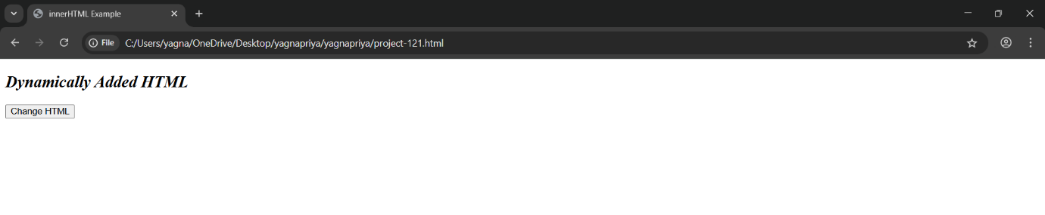

**Project-123**

**Title: Demonstrate hoe to update visible text using ‘innerText’ with a button.**

**Source Code:**

<!DOCTYPE html>

<html>

    <head>

        <style>

            .hidden {display: none;}

        </style>

    </head>

    <body>

        <div id="note"><span class = "hidden">Hidden</span>Message</div>

        <p id="output"></p>

        <button onclick="showInnerText()">Get innerText</button>

        <script>

           function showInnerText() {

            document.getElementById("output").textContent=document.getElementById("note").innerText;

           }

        </script>

    </body>

</html>

**Output:**

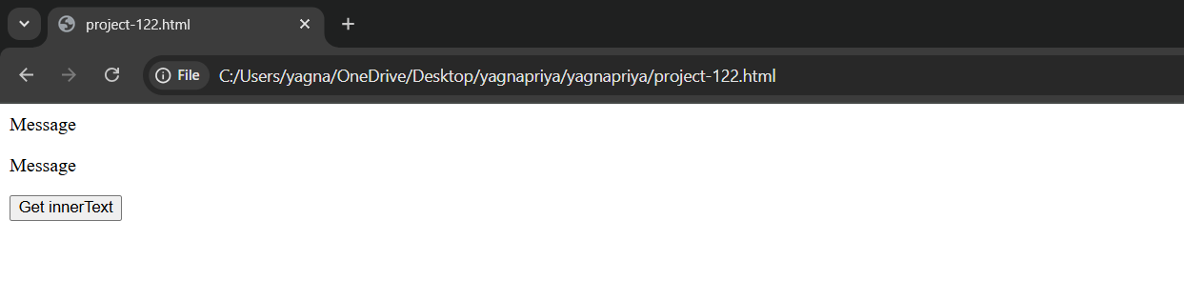

**Project-124**

**Title: Demonstrate how to create an element by clicking a button.**

**Source Code:**

<!DOCTYPE html>

<html>

    <head>

        <title>Create Element on Click</title>

    </head>

    <body>

        <button onclick="createPara()">Add Paragraph</button>

        <div id="output"></div>

        <script>

            function createPara() {

                let para = document.createElement("p");

                para.textContent = "This paragraph was added by clicking the button.";

                document.getElementById("output").appendchild(para);

            }

        </script>

    </body>

</html>

**Output:**

